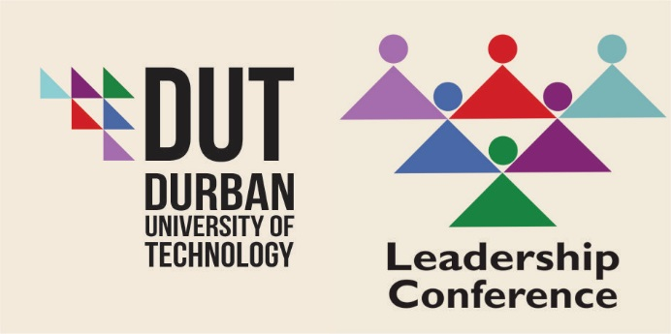
Complexities of Leadership in the 21st Century
25 – 26 August 2016
International Convention Centre (ICC)
Durban
Project Leader: Mrs Manoshni Perumal
THURSDAY, 25 AUGUST 2016 (DAY 1) (FACILITATOR - DR MARTIN MANDEW)

08:00 – 09:00 | Registration and Refreshments
09:00 – 09:15 | Welcome | Dr Jairam Reddy
09:15 – 09:30 | SA National Anthem | Natalie Rungan
09:30 – 09:45 | Introduction of Keynote Speaker | Eric Apelgren
09:45 – 10:25 | Key Note Speaker: Courageous Leadership | Adv. Thuli Madonsela
10:25 – 10:40 | Respondent | Dr Jairam Reddy
10:40 – 11:00 | Networking and Refreshments
SESSION 1: CHAIR (DR J VOLMINK)
11:05 – 11:45 | Ethics of Higher Education in Social Justice  (Empathy and the Ethics of Leadership) | Prof Pumla - Gobodo Madikizela
11:45 – 12:00 | Wrap Up/Questions and Answers | Dr John Volmink/Prof Pumla - Gobodo Madikizela
SESSION 2: CHAIR (DR R SMITH)
12:05 – 12:45 | Positioning Women for Leadership  (How to Survive in a Hyper Masculine Space) | Prof Monique Marks
12:45 – 13:00 | Wrap Up/Questions and Answers | Dr Rene Smith/  Prof Monique Marks
13:00 – 14:00 | Lunch
PANEL DISCUSSION: GENDER EQUITY IN LEADERSHIP (CHAIR: PROFESSOR T PUCKREE)
14:05 – 15:05 | ‘M’ Generation in Higher Education  (Global Challenges and Interdisciplinary Collaboration) | Dr Adriana Marais
 | Risk and Resilience: Fear of failure | Ela Gandhi
 | ‘Breaking the Glass Ceiling’  (Ability and Leadership is Sexless: On Breaking the Glass Ceiling within the Higher Education Sector) | Prof Thenjiwe Meyiwa
 | A Success Story! | Lindiwe Rakharebe
15:05 – 15:25 | Wrap Up/Questions and Answers | Prof Puckree/Panel
SESSION 3: CHAIR (DR M MANDEW)
15:30 – 16:10 | Vampires and Zombies: A Typology of Leadership in Higher Education | Prof Anthony Collins
16:10 – 16:25 | Wrap Up/Questions and Answers | Dr Martin Mandew/Prof Anthony Collins
16:25 – 16:30 | Closure | Dr Martin Mandew
16:30 | Networking and Refreshments

Gala Evening (Thursday, 25 August 2016)
Entertainment (Combination of Jazz and Comedy)
18:30 – 23:00 | Welcome | Prof T N Andrew
 | Entertainment | Natalie Rungan &  Masood Boomgaard

FRIDAY, 26 AUGUST 2016 (DAY 2) (FACILITATOR - PROFESSOR T N ANDREW)

08:30 – 09:00 | Tea/Coffee
09:00 – 09:05 | Introduction of Key Note Speaker | Prof T N Andrew
09:05 – 09:45 | Key Note Speaker: Complexities in Higher Education and Collaboration between Universities | Prof Ahmed Bawa
09:45 – 10:00 | Wrap Up/Questions and Answers | Dr Volmink /  Prof Ahmed Bawa
SESSION 4: CHAIR (PROFESSOR S SINGH)
10:05 – 10:45 | Engaging Transformation in Higher Education | Prof Brian Figaji
10:45 – 11:00 | Wrap Up/Questions and Answers | Prof Singh/ Prof Brian Figaji
11:00 – 11:20 | Networking and Refreshments
PANEL DISCUSSION: ENGAGING UNIVERSITIES,COMMUNITIES AND BUSINESSES FOR IMPROVED PARTNERSHIPS (CHAIR: PROFESSOR T N ANDREW)
11:25 – 12:25 | Community Engagement  (A critical examination of the role of tertiary institutions in building resilient communities - challenges and possibilities) | Dr Rama Naidu
 | Community Engagement  (The LEADER-ship Complexity of “Community” Engagement in South African Higher Education) | Dr Bernadette Johnson
 | University Engagement  (Towards Developing Models for Shared Leadership in South African Higher Education Institutions) | Prof Sibusiso Moyo
 | Corporate Business Partnership  (Partnerships: Universities and Business) | Dr Stan Hardman
12:25 – 12:45 | Wrap Up/Questions and Answers | Prof Andrew/Panel
12:45 – 13:45 | Lunch
SESSION 5: CHAIR (PROFESSOR S MOYO)
13:50 – 14:30 | Innovation for Sustainability within Higher Education | Prof Loyiso Nongxa
14:30 – 14:45 | Wrap Up/Questions and Answers | Prof Moyo/Prof Loyiso Nongxa
14:45 – 15:00 | Closing Remarks | Dr John Volmink

