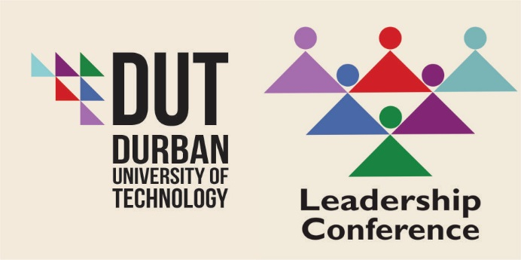

Complexities of Leadership in the 21st Century
International Convention Centre (ICC)
Durban
2016

CONTENTS

DESCRIPTION | PAGE NO
MESSAGE FROM THE INTERIM VICE-CHANCELLOR | 3
MESSAGE FROM THE SENIOR DIRECTOR: HUMAN RESOURCES | 4

Message from the Interim Vice-Chancellor - (DUT)

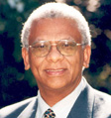 Dr John Volmink

Dr John Volmink was born and raised in Cape Town South Africa. He started his academic career at the University of Western Cape, South Africa and completed the PhD in Mathematics Education at Cornell University, Ithaca NY in 1988.

He started his career as a high school teacher and later became the Head of Mathematics at the then Peninsula Technikon. He also held various other teaching positions including the University of Western Cape, University of Cape Town and Cornell University. He returned to Southern Africa in 1990 after almost a decade in the USA.
After a brief stay at the University of Botswana in Gabarone, Dr Volmink returned to South Africa in 1991 and immediately got involved in development initiatives as the Director of the Centre for Advancement of Science and Mathematics Education in Durban, South Africa, as well as other partnership programmes in KwaZulu-Natal and elsewhere in South Africa. Dr Volmink later served as Campus Vice-Principal at the then University of Natal (now UKZN), Durban, and later Pro-Vice Chancellor: Partnerships at the University of KwaZulu-Natal until 2004. During his term at the University of KwaZulu-Natal, he was responsible for partnership programmes with business, government and the community and served as the Executive Director of the Development Foundation of the University.

Dr Volmink has also been centrally involved in curriculum reform in post-apartheid South Africa and has been asked by all four Ministers of Education to play a leading role in the transformation of education in the new South Africa. He served as the Chairperson of the Umalusi Council, the statutory body that monitors and improves the quality of general and further education and training in South Africa for four years (2006-2010) and has just been re-appointed by the Minister for a further four years commencing June 2014. Also more recently he served as the first CEO of the National Education Evaluation and Development Unit (NEEDU). He was the Principal and Chief Executive Officer of Cornerstone Christian College for five years.

Message

On behalf of the Durban University of Technology, it gives me great pleasure to welcome you to our 2016 Leadership Conference

The theme of the conference draws attention to the complex challenges confronting leadership in Higher Education in our country at this time. This Leadership Conference is designed to help leaders and managers reflect on these challenges and to provide a platform to discuss ways to live into these as possibilities and to re-imagine fresh responses to these challenges. We believe that leaders will be better able to successfully navigate these challenges by building a network of connections in order to share thoughts, experiences and understanding of the complexities faced by leadership in the 21st Century.

We have been fortunate to have attracted some of the best minds in our country to this Conference and we are deeply honored by your presence. You have made this Conference a memorable and proud moment in the institutional memory of our University.

I am delighted that this conference is taking place during my time as Interim Vice-Chancellor. I would like to congratulate Dr Matata Mokoele, the Senior Director of Human Resources Division and Ms Manoshni Perumal, Manager of the Skills and Professional Development in the HR Division, taken the opportunity to creatively engage with me and structuring this Conference so that we would have a meaningful experience here as a learning community.

We look forward to our time with you over the next two days and trust that we will leave here with a greater willingness and confidence to embrace our current and future challenges.

Senior Director Human Resources (DUT)

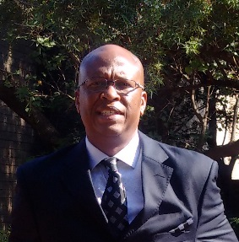 DR JOHANNES MATATA MOKOELE

On behalf of the Conference Management Committee, I extend a very warm welcome to what will be an excellent inaugural Leadership Conference. I welcome your contributions to the programme and full participation in plenaries, panel discussions and general interest activities planned for the event.

We have a full two-days to learn about these areas of importance, particularly in the times when leadership competence in many South African organisations is under public scrutiny. The field of complexity leadership theory and practice is still young and will require considerable research to substantiate its claims and realise its full potential. Complexity leadership is not a panacea for our leadership problems and never will be. No matter how much research backs its findings, it will continue to require supplemental perspectives to fully map the leadership terrain. Nonetheless, it offers one of the most important ways to reflect upon and engage in leadership. Our organisational environments are becoming increasingly complex, and the complexity leadership approach is grounded in decades of research in how to work with complex systems. Fundamentally, its insights and guidelines provide additional hope and inspiration that we will collectively learn how to handle the global social, economic and environmental challenges that symbolise today’s world.

I commend the Conference Management Committee for producing an exciting, interactive conference programme led by Manoshni Perumal and an impressive array of academic, researchers and practitioners. The conference is designed to be a high impact experience for incumbent and aspiring school leaders.

We have brought, among others, top-tier keynote speakers including Advocate Thuli Madonsela, who made a name for herself globally as the South African Public Protector, a human rights lawyer and equality expert. She is also one of Time Magazine’s 100 most influential people of 2014 and served on the team that helped draft South Africa’s final constitution, put into effect by the late President Nelson Mandela in 1996. We are also excited to have talented leaders such as Professor Ahmed Bawa who will contribute his expert knowledge on Higher Education and the many other topics in management leadership and its related complexities.

This conference would not have been possible without an incredible group of people behind it; a group which has a vision to make this conference the cornerstone of our growth in the coming years. Their passion and commitment to giving back to the leadership community is what has made this possible, and I know they are as excited as I am to see you.
You have my best wishes for a wonderful professional and personal experience!

Sincerely,

CONFERENCE OVERVIEW
Visionary leaders have the ability to see a preferred future, operate in the present and utilise the resources around them to map out a clear path to a new future. Leaders of tomorrow imagine a future that is rich and full of hope; a future where problems are solved, questions are answered and new frontiers are created.
OBJECTIVES
Our special focus includes:
- Leading growth and innovation;
- Thriving amidst uncertainty;
- Building enduring organisations;
- How should individuals and organisations best prepare for expanding and innovating;
- Coping with faster rates of change and greater uncertainties;
- Building leadership teams and organizational architectures that are competitive and sustainable.

THEMES

- Courageous Leadership
- Ethics of Higher Education in Social Justice (Empathy and the Ethics of Leadership)
- Positioning Women for Leadership (How to Survive in a Hyper Masculine Space)
- Panel Discussion: Gender Equity in Leadership
  - ‘M’ Generation in Higher Education (Global Challenges and Interdisciplinary Collaboration)
  - Risk and Resilience: Fear of Failure
  - ‘Breaking the Glass Ceiling’ (Ability and Leadership is Sexless: On Breaking the Glass Ceiling within the Higher Education Sector)
- Vampires and Zombies: A Typology of Leadership in Higher Education
- Complexities in Higher Education and Collaboration between Universities
- Engaging Transformation in Higher Education
- Panel Discussion: Engaging Universities, Communities and Businesses for Improved Partnerships
- Community Engagement
- University Engagement (Towards Developing Models for Shared Leadership in South African Higher Education Institutions)
- Corporate Business Partnerships (Partnerships: Universities and Business)
- Innovation for Sustainability within Education

Complexities of Leadership in the 21st Century
25 – 26 August 2016
International Convention Centre (ICC)
Durban
Project Leader: Mrs Manoshni Perumal
THURSDAY, 25 AUGUST 2016 (DAY 1) (FACILITATOR - DR MARTIN MANDEW)

08:00 – 09:00 | Registration and Refreshments
09:00 – 09:15 | Welcome | Dr Jairam Reddy
09:15 – 09:30 | SA National Anthem | Natalie Rungan
09:30 – 09:45 | Introduction of Keynote Speaker | Eric Apelgren
09:45 – 10:25 | Key Note Speaker: Courageous Leadership | Adv. Thuli Madonsela
10:25 – 10:35 | Respondent | Dr Jairam Reddy
10:35 – 11:00 | Networking and Refreshments
SESSION 1: CHAIR (DR J VOLMINK)
11:05 – 11:45 | Ethics of Higher Education in Social Justice  (Empathy and the Ethics of Leadership) | Prof Pumla - Gobodo Madikizela
11:45 – 12:00 | Wrap Up/Questions and Answers | Dr John Volmink/  Prof Pumla - Gobodo Madikizela
SESSION 2: CHAIR (DR R SMITH)
12:05 – 12:45 | Positioning Women for Leadership  (How to Survive in a Hyper Masculine Space) | Prof Monique Marks
12:45 – 13:00 | Wrap Up/Questions and Answers | Dr Rene Smith/  Prof Monique Marks
13:00 – 14:00 | Lunch
PANEL DISCUSSION: GENDER EQUITY IN LEADERSHIP (CHAIR: PROFESSOR T PUCKREE)
14:05 – 15:05 | ‘M’ Generation in Higher Education  (Global Challenges and Interdisciplinary Collaboration) | Dr Adriana Marais
 | Risk and Resilience: Fear of failure | Ela Gandhi
 | ‘Breaking the Glass Ceiling’  (Ability and Leadership is Sexless: On Breaking the Glass Ceiling within the Higher Education Sector) | Prof Thenjiwe Meyiwa
15:05 – 15:25 | Wrap Up/Questions and Answers | Prof Puckree/Panel
SESSION 3: CHAIR (DR M MANDEW)
15:30 – 16:10 | Vampires and Zombies: A Typology of Leadership in Higher Education | Prof Anthony Collins
16:10 – 16:25 | Wrap Up/Questions and Answers | Dr Mandew/  Prof Anthony Collins
16:25 – 16:30 | Closure | Dr John Volmink
16:30 | Networking and Refreshments

Gala Evening (Thursday, 25 August 2016)
Entertainment (Combination of Jazz and Comedy)
18:30 – 23:00 | Welcome | Prof T N Andrew
 | Entertainment | Natalie Rungan & Masood Boomgaard

FRIDAY, 26 AUGUST 2016 (DAY 2) (FACILITATOR - PROFESSOR T N ANDREW)

08:00 – 08:30 | Tea/Coffee
08:30 – 08:35 | Introduction of Key Note Speaker | Prof T N Andrew
08:35 – 09:15 | Key Note Speaker: Complexities in Higher Education and Collaboration between Universities | Prof Ahmed Bawa
09:15 – 09:35 | Wrap Up/Questions and Answers | Dr Volmink/Prof Ahmed Bawa
SESSION 4: CHAIR (PROFESSOR S SINGH)
09:40 – 10:20 | Engaging Transformation in Higher Education | Prof Brian Figaji
10:20 – 10:35 | Wrap Up/Questions and Answers | Prof Singh/Prof Brian Figaji
10:35 – 11:00 | Networking and Refreshments
PANEL DISCUSSION: ENGAGING UNIVERSITIES,COMMUNITIES AND BUSINESSES FOR IMPROVED PARTNERSHIPS (CHAIR: PROFESSOR T N ANDREW)
11:05 – 12:05 | Community Engagement (A critical examination of the role of tertiary institutions in building resilient communities - challenges and possibilities) | Dr Rama Naidu
 | Community Engagement | Dr Bernadette Johnson
 | University Engagement  (Towards Developing Models for Shared Leadership in South African Higher Educations Institutions) | Prof Sibusiso Moyo
 | Corporate Business Partnership  (Partnerships: Universities and Business) | Dr Stan Hardman
12:05 – 12:25 | Wrap Up/Questions and Answers | Prof Andrew/Panel
SESSION 5: CHAIR (PROFESSOR S MOYO)
12:30 – 13:10 | Innovation for Sustainability within Higher Education | Prof Loyiso Nongxa
13:10 – 13:25 | Wrap Up/Questions and Answers | Prof Moyo/Prof Loyiso Nongxa
13:25 – 13:30 | Closing Remarks | Dr John Volmink
13:30 | Lunch

DUT LEADERSHIP CONFERENCE SPEAKERS

DR JOHN VOLMINK  Vice-Chancellor (Interim)- Durban University of Technology | 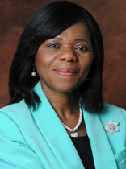  ADVOCATE THULI MADONSELA  Key Note Speaker- Public Protector | 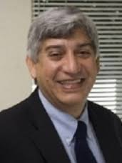  PROFESSOR AHMED BAWA  CEO - Universities South Africa (USAF) | 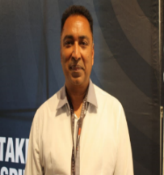  DR RAMA NAIDU  Executive Director - Democracy Development Programme | 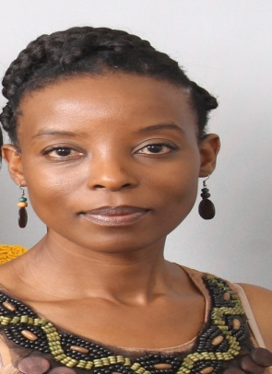  PROFESSOR SIBUSISO MOYO  Research and Postgraduate Support Director & DVC: Engagement (Acting)- Durban University of Technology
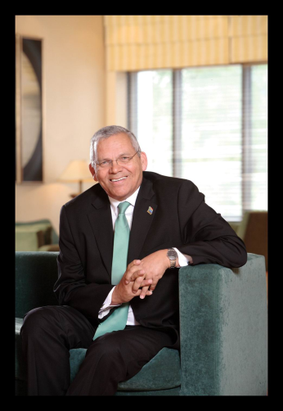  PROFESSOR BRIAN FIGAJI  Former Vice-Chancellor (President) - Cape Peninsula University of Technology | DR ADRIANA MARAIS  Postdoctoral Researcher – Quantum Research Group- University of KwaZulu-Natal | 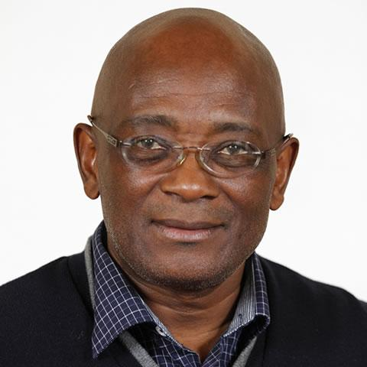  PROFESSOR LOYISO NONGXA  Former Vice-Chancellor - University of the Witwatersrand (Wits) | 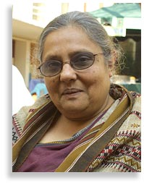  ELA GANDHI  Peace Activist | 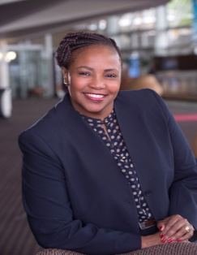  LINDIWE RAKHAREBE  Chief Executive Officer- Durban International Convention Centre (ICC)
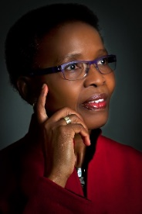  PROFESSOR PUMLA GOBODO-MADIKIZELA  Senior Research Professor in Trauma Forgiveness and Reconcilliation | 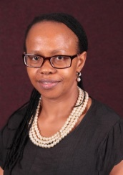  PROFESSOR THENJIWE MEYIWA  Institutional Registrar - Durban University of Technology | 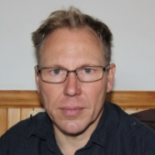  PROFESSOR ANTHONY COLLINS  Professor of Media, Language and Communication- Durban University of Technology | DR BERNADETTE JOHNSON  NRF grant holder studying Community Engagement - South African Higher Education | 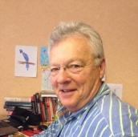  DR STAN HARDMAN  Director and Programme Developer
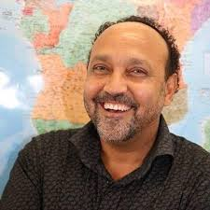  ERIC APELGREN  Head of International and Governance Relations – eThekwini Municipality | 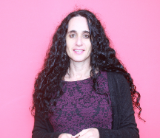  PROFESSOR MONIQUE MARKS  Urban Future Centre (DUT)

Key Note Speaker- Public Protector

ADVOCATE THULI MADONSELA

Advocate Thulisile (Thuli) Nomkhosi Madonsela was appointed as the South African Public Protector by President Jacob Zuma on the recommendation of Parliament with effect from 15 October 2010. At the time of her appointment, Adv. Madonsela was the only full-time Commissioner in the South African Law Reform Commission. Before then, she held various leadership positions in civil society and the public sector. These include a membership on the Inaugural Commission on Employment Equity and the Steering Committee of the legal Services Charter and various executive management positions in the Department of Justice and Constitutional Development.

One of the eleven Technical Experts that assisted the Constitutional Assembly in drafting South Africa’s new Constitution, Adv. Madonsela is a human rights lawyer, equality expert, constitutional analyst and policy specialist who holds a BA Law and LLB degrees. She has also done post graduate studies in various areas of the law, including Constitutional Law, Equality, Administrative Justice and Developmental Law. Her postgraduate studies include executive leadership courses in areas such as leadership; strategic planning, project management and Alternative Dispute Resolution (ADR).

She is the co-architect of the Promotion of Equality and Prevention of Unfair Discrimination Act, the Employment Equity Act and Local Government Transition Act. She has also contributed to laws such as the Promotion of Administrative Justice Act, Repeal of the Black Administration Act, Recognition of Customary Marriages Act and the Reform of Customary Law and Related Matters Act. She has played a central role in the drafting of various transformational policies and related instruments which include Justice Vision 2000, the Victims Charter, National Gender Policy Framework and the policy framework that formed the basis of the Ministry for Women, Children and Disability Affairs.

Topic: Courageous Leadership

CEO - Universities South Africa- (USAF)

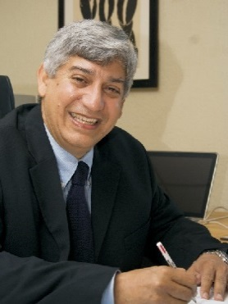 PROFESSOR AHMED BAWA

Professor Ahmed Bawa is a theoretical physicist. He currently holds the position of Chief Executive Officer of Universities South Africa (USAf).

Until the end of April 2016, he was Vice-Chancellor and Principal at the Durban University of Technology. Until August 2010, he was a faculty member at Hunter College of the City University of New York where he was a member of Department of Physics and Astronomy. He was also a member of the Doctoral Faculty at the Graduate Centre, also of the City University of New York. During this period, Prof Bawa was also Associate Provost for Curriculum Development at Hunter College. He had previously, for about nine years, held the position of Deputy Vice-Chancellor at the then University of Natal (now UKZN) and then at the University of KwaZulu-Natal.

He has served as the Program Officer for Higher Education in Africa with the Ford Foundation and during this time, led and co-ordinated the Foundation’s African Higher Education Initiative. During this time, he worked closely with the Association of African Universities, the Council for the Development of Social Research in Africa, etc.

Prof Bawa holds a PhD in Theoretical Physics from the University of Durham, UK. He has published in the areas of high energy physics, nuclear physics, higher education studies, science education and to some extent in the area of science and society.

He served on a number of policy development teams in the post-1994 period and was an inaugural member of the National Advisory Council on Innovation until 2002. He is Fellow of the Royal Society of South Africa as well as the Academy of Science of South Africa of which he was one of the inaugural vice-presidents. He also served as Chair of the Board of the Foundation for Research Development and later served on the Board of the National Research Foundation and was Vice-Chairman of the board the Atomic Energy Corporation. Prof Bawa also serves on several international advisory boards.

Topic: Complexities in Higher Education and Collaboration Between Universities
Presentation Overview:
While universities appear to be very stable, slow-acting institutions, they are in fact massively complex, multi-layered institutions that are constantly shaped ad reshaped through internal and external dynamics. All we have to do is witness the vulnerability of these institutions to instabilities caused by student demonstrations. They are also nonlinear in nature because of the way in which different layers of people and different layers of purpose interact with each other often under conditions of contestation.
This nonlinearity makes it difficult to shape direct, straightforward solutions to their functioning which may from time to time lead to rather catastrophic outcomes. One way of addressing this issue is to think of developing positive teamwork through the creation of networks of individuals across functioning domains to foster new forms of learning that allow for interventions that systemic in nature and to inculcate in staff the knowledge of and understanding of 'nudging' skills.

Professor of Media, Language and Communication-(DUT)

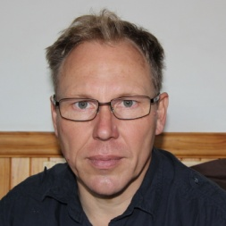 PROFESSOR ANTHONY COLLINS

Professor Anthony Collins has an interdisciplinary critical social sciences background which includes cultural studies, psychology, and media studies. He holds a PhD from the University of California, Santa Cruz, and has worked at Rhodes University, Wits, and UKZN. Much of his academic work has entailed developing new South African curriculum by applying critical theoretical frameworks to current social problems, for which he was awarded both a UKZN Distinguished Teacher Award and a HELTASA National Excellence in Teaching and Learning Award. His academic work can be found online at https://rhodes-za.academia.edu/AnthonyCollins and https://www.researchgate.net/profile/Anthony_Collins3/

Topic: Vampires and Zombies: A Typology of Leadership in Higher Education
Presentation Overview:
This is a story of monsters and humans in the contested context of South African universities. It explores the relationship between institutional culture and governance, revealing several competing ideas of what universities are and should be, and how these shape ideas of good leadership. It maps competing processes of transformation, including the negative and hidden forms of transformation that are overlooked in progressive debates. Here the tensions between democratic and authoritarian governance are clarified, and the analysis maps the connections between university cultures and leadership styles. These are linked to conflicting ideas of the university, as either a public resource for benefit of democratic society, or as a type of corporation ranked in terms of financial viability and technical measures of excellence. This becomes a tale of the struggle between vampires, zombies, and humans in our scary story.

Executive Director - Democracy Development Programme
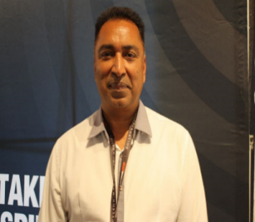 DR RAMA NAIDU

Dr Rama Naidu is the Executive Director of the Democracy Development programme. The Programme was initiated in 1993 in South Africa to consolidate and promote a democratic culture through research, capacity building, advocacy and civic engagement.

Dr Naidu has been involved in research, materials development, strategic planning, facilitation, budgeting and organisational development for the past 13 years. Dr Naidu has written several articles and edited publications on issues of public participation and civic engagement and is passionate about ethical leadership and the intricacies of organisational culture and transformation.

He has been involved in senior leadership positions for the past 20 years both in the academic and in the civil society sector. He holds a Doctorate in Social Geography and has been a fellow of North Western University in Chicago. He has also completed two international courses in organisational development and has consulted both nationally and internationally, specialising in the area of civic education and citizen participation. His clients included GTZ, the European Union, the African Union and several local non-government organisations. He has served as an executive member of the Pan African Civic Educators Network for five years and presently serves as an executive member of the KwaZulu-Natal Civil Society Coalition.

Topic: Community Engagement
(A critical examination of the role of tertiary institutions in building resilient communities - challenges and possibilities)
Presentation Overview:
Tertiary institutions ought to play an important position in reshaping society in order to cope with the complexities of the present day development paradigm. However, there seems to be a disconnect between knowledge generated and the transfer to society in a way that makes it useful for sustainable development, particularly at the level of local communities. The present situation in South Africa requires us to take a critical look at their leadership role in bringing about societal change. Such change has to be related to both the local and global context and to engage more with the notion of what is required to build and equip a cadre of future thinkers that are innovative, resourceful and community focused.
More specifically, the relationship between teaching, research, and actual work in communities has not been deeply interrogated enough by the “tertiary community” in a way that sees the role of these institutions as part of a more holistic approach to sustainable development. Such an interrogation has to talk to the actual possible role of these institutions in the eradication of poverty and the production of new knowledge that would shape and influence the decisions of multiple stakeholders in very tangible and practical ways.
This presentation explores some of these possibilities and raises questions that we need to engage with critically and intentionally in order for tertiary institutions to assume a more central role in leading societal change.

DR BERNADETTE JOHNSON

Dr Bernadette Johnson has for the past 25 years served the Higher Education sector in South Africa. She is currently an NRF grant holder studying Community Engagement in South African Higher Education. Her research is strategically focused on building Engagement in Higher Education in the South with a special focus on the University in Africa. In her position as the Chairman of the South African Higher Education Community Engagement Forum (SAHECEF), she is committed to making a contribution towards building Engaged Scholarship within the Higher Education system.

Dr Johnson is currently Executive Director: Office of the Vice-Chancellor; Professor: IN Moutlana at the Vaal University of Technology. She is extremely proud of having the honour of working with Professor Moutlana who is one of the few serving African female vice-chancellors in the country. Under her leadership, Dr Johnson has a special focus from the Office of the Vice-Chancellor on Institutional Planning and Communication Strategy.

As an undergraduate student at UCT and postgraduate student at UWC, Dr Johnson grew up as a student activist involved in student representative councils, student political organisations regionally and nationally as well as community organisations and the trade union movement.

It was from her student activism in higher education at UCT and UWC that she decided to develop her scholarship in the field of higher education. Dr Johnson served at branch and regional leadership positions in SASCO and on three consecutive student representative councils at UWC during the late 1990s. Her publications are focused on management, leadership and governance in higher education. She has received numerous scholarships and awards including a Carnegie Award and the opportunity to study in Australia and the United States at Stanford University. Given her past seven-year experience in Research Leadership as Executive Director: Research, she has also published in the area of Research Development in Higher Education and the Knowledge Economy and Innovation. Previously, she also worked at the Department of Education responsible for Higher Education Planning and as a lecturer at the University of Witwatersrand and Khanya College. She has had the opportunity to work for PALAMA, lecturing in Policy and Leadership and Management for Senior Government Officials in South Africa and in East Africa. She has been a Research Associate both at the University of the Witwatersrand’s Sociology Department and at the University of Johannesburg. She currently supervisors Master’s and Doctoral students.

Topic: Community Engagement
Presentation Overview
University leaders agree that community engagement (CE) is a powerful mission through which the university contributes to social justice. Yet, ironically CE is experienced as a neglected mission. Hindering its full potential is the central subject of consideration in this paper. Preliminary findings indicate that one of the greatest enablers is leadership, yet there are system complexities. This paper focuses on exploring emerging areas of focus required for university leaders to navigate the implementation of CE in South African universities. These areas are informed by research conducted using a Meta-Participatory Action Research methodology. Research methods include: (i) semi-structured interviews with community engagement managers, directors and deputy vice-chancellors; (ii) reflections on focus group discussions within SAHECEF; (iii) documentary analysis and (iii) a literature analysis of research on how universities engage with their communities. While the study focuses on university-based community engagement officials, further research is required on what academicians and communities regard as the barriers to engagement. The paper extends an impassioned invitation to university leaders to actively pursue an agenda that once again places the purpose of the university in development at the center of strategy through stimulating enabling conditions for the engaged African university.

Director and Programme Developer
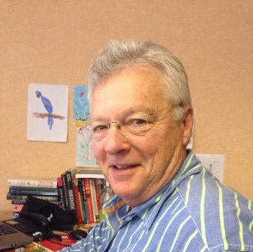 DR STAN HARDMAN

Dr Stan Hardman has broad experience in school education, education administration and the NGO sector. He also has business involvement in education. His focus is on leadership education with in a Systems Thinking and Complexity Science framework. Within this is his interest on inter-sector partnerships, their theorisation, application and the ethical implications. His focus has been on education innovation and the creative inspiration of others rather than on self.
The Leadership Dialogue, is an organisation dedicated to resilient leadership learning for a better tomorrow through using systems thinking and complexity science.

B.A., M. Ed (Natal), Dip Spec Ed (UNISA) P G Cert. in Cross-Sector Partnerships (Programme for Industry) Cambridge), D.B.A. (UKZN)
Director and Programme Developer

Topic: Partnerships: Universities and Business
Presentation Overview:
Change is ubiquitous, with Higher Education being no different. Universities as leading institutions in Higher Education have multiple mandates three of which are (i) critical engagement with knowledge in relation to the human condition and ii) preparing students for professional life in the emerging context and (iii) providing continuing professional development for those in the workplace. These three are directly connected to the relationship between business and universities.
This relationship is a complex one involving ideology, conceptualisation, policy frameworks, hierarchy and institutional arrangements and cannot be reduced to stereotypes. It implies multiple arrangements which require flexibility and agility.
In this paper, the focus is on the processes of (i) reframing, (ii) resources, (iii) relationships and (iv) reagents.
Key ideas include mind set, nexus, bridging institutions, inter-group agility and social reagents.

Chief Executive Officer - Durban International Convention Centre
LINDIWE RAKHAREBE
Lindiwe Rakharebe joined the Durban International Convention Centre as Chief Executive Officer at the beginning of April 2015. She holds a Bachelor’s Degree in Management Leadership from the University of the Free State as well as other several qualifications in Marketing Management and Management Development. Prior to taking the reins at the Durban ICC, Lindiwe served in a management capacity for all four of South Africa’s major banking institutions.

Topic: A Success Story!
Presentation Overview:
Lindiwe’s leadership style is characterised by love, respect and open communication.
She believes that success is ultimately the result of diligent management, strong collaborative relationships and an attitude of perpetual learning.
Lindiwe’s talk will focus on her passion for leadership and how she is able to bring out the best in the teams she leads. She will impart insights into her unique style of motivation and inspiration and will be sharing lessons she has learnt from her own experience as a woman in leadership in the business world.
Over her 30 years in the corporate environment, Lindiwe has repeatedly proven her ability in strategic management and leading high-performance teams. Lindiwe places a premium on customer service and respect, as well as the importance of work-life balance.
Her areas of expertise include strategic planning, research, marketing, community liaison, policy development and the principles of good corporate governance.

Research and Postgraduate Support Director and DVC: Engagement (Acting) - (DUT)

PROFESSOR SIBUSISO MOYO

Professor S Moyo holds a PhD in Mathematics from the University of Natal, Durban and a Masters in Tertiary Education Management from the LH Martin Institute, University of Melbourne Australia. As a scholar, she has published widely in the Mathematical Sciences and continues to supervise and mentor Masters and Doctoral students. She has also served as Guest Editor of the Mathematical Methods in the Applied Sciences Journal (published by John Wiley & Sons) and Journal of Engineering Mathematics (published by Springer). She is also responsible for developing staff programmes to assist staff complete their PhDs and delivering short courses on Research Methodology, Research Design, Data handling techniques and Modelling techniques.
Her current research projects involve applications using group theoretic techniques in problems arising from nonlinear phenomena with applications in Mathematical Biology and Financial Mathematics. In addition, her current areas of interest also extend to strategic research that aims to inform research and postgraduate policies within the higher education sector, promoting mathematics amongst the youth and mentoring young women to become leaders in their chosen fields of interest.

Topic: University Engagement
(Towards Developing Models for Shared Leadership in South African Higher Education Institutions)
Presentation Overview:
The South African higher education landscape has undergone a number of changes over the last decade and in more recent times – periods of disruptive changes. The current issues have to deal with massive expansion and demand for access, transformation, equity, funding for the majority of under privileged students, responding to government priorities, funders and internal and external pressures, and the rise in private higher education providers to mention a few. Within this context I try to understand what effective approaches and programmes are required in developing leaders of high quality that can deal with the complex higher education landscape. I look at the roles that distributed leadership as part of the shared leadership debate can play to enhance leadership skills and create enabling university environments. I further argue that responding to regional, national and international pressures while focusing on the main institutional missions of teaching and learning, research and engagement require a number of effective drivers of which inclusive shared leadership is central.

Former Vice-Chancellor (President) - Cape Peninsula University of Technology
PROFESSOR BRIAN DE LACY FIGAJI

Professor Brian Figaji studied at the universities of the Western Cape (UWC), Cape Town (UCT), University of South Africa (UISA) and Harvard University in the USA.

He practiced as a professional engineer for 10 years in both contracting and design and then joined Peninsula Technikon which subsequent to the merger of 2004 became known as the Cape Peninsula University of Technology. Prof Figaji served the institution for 25 years, with 10 of these years as Vice-Chancellor (President). He left the institution in 2004 in opposition to the pending merger.

Among the many positions he held the most relevant positions were as:
- Member, and later Vice-President of the Engineering Council of South Africa;
- Member of the South African Council on Higher Education;
- Representative of SA on the UNESCO Executive Board from 2005 to 2009;
- Chair of the SA National Commission for UNESCO from 2009 to 2013; and
- Member of the Council advising the President on National Orders (National Presidential Awards) until 2014.
Prof Figaji is also a Fellow of the Society for Professional Engineers, Fellow of the Institute for Civil Engineers, Fellow of the Academy of Engineering and a member of the Academy of Science of SA.

In the context of civil society, he serves on education trusts as well as various boards including performing arts, Blood Transfusion Services, Scout Association as well as a body serving the needs of war-blinded individuals. He is also the non-executive Chair of one of the large fishing companies in the country and is also the Chairman of Wesgro.

Topic: Engaging Transformation in Higher Education
Presentation Overview:
Since the dawn of democracy, educators in SA have been preoccupied with the issue of transformation even though there has never really been a nationally accepted definition of what we mean by transformation. However, from the objectives set by the Department of Education and the strategic plans of higher education institutions, there has been a push in a particular direction for change. In the beginning, the major focus was on access, equity and redress. As these aspects were being addressed, new areas requiring transformation unfolded. So, while there has been much progress, there is no definitive measure that could help institutions gauge the extent to which they have succeeded, and how far they still need to go on specific areas of focus.
Fundamental to the change agenda of any programme of transformation are the people who have to contribute to the building of this new form. In higher education, this translated to the students, academic staff, research staff, management, workers and all those who are employed within the institution to support the teaching and learning mission. All these constituent parts need to work together if transformation is going to be effective and long lasting.
Inevitably, this brings us to the need for effective institutional leadership at a number of levels. A leadership model that adopts a team approach will be proposed as the vehicle for engaging with transformation in higher education.

Postdoctoral Researcher - Quantum Research Group - University of KwaZulu-Natal

DR ADRIANA MARAIS
Dr Adriana Marais studied theoretical physics and philosophy at the University of Cape Town. She completed her MSc summa cum laude in Quantum Cryptography at the University of KwaZulu-Natal and was awarded her PhD in Quantum Biology at the same institute in 2015. She is a member of the Quantum Research Group established by Professor Francesco Petruccione at UKZN and plans to continue doing research in Quantum Biology, specifically studying quantum effects in photosynthesis as well as the origins of prebiotic molecules and life itself.

In 2014, Dr Marais was one of 200 Young South African Achievers recognised by the Mail & Guardian. In 2015, she was one of 15 recipients worldwide of a L’Oreal‐UNESCO International Rising Talent Grant for Women in Science for her research into the origins of life. This year (2016), she is the Royal Society of South Africa 2016 Meiring Naude Medal awardee for a young researcher for fundamentally important high impact research in the field of Quantum Biology. This June, she attended the prestigious 66th Lindau Nobel Laureate Meeting as one of 400 most qualified young physicists selected worldwide.

Since childhood, she has dreamed of living on another planet and is currently one of the 100 Mars One Project astronaut candidates in the running to move to the red planet in 2026. She hopes one day to continue her research on Mars, and possibly even contribute to the discovery of evidence that life once existed there.

Dr Marais believes that education comes with the responsibility to share knowledge, and while still on Earth, is actively involved in the promotion of science and space exploration as Special Project Co-ordinator for the Foundation for Space Development South Africa; an exciting initiative of which is the Africa2Moon project. She has given numerous talks since 2014, inspiring school children, teenagers and adults around South Africa and abroad to get excited about science, believe in their dreams and remember Nelson Mandela’s words, “It always seems impossible until its done”.
Topic: ‘M’ Generation in Higher Education
(Global Challenges and Interdisciplinary Collaboration)
Presentation Overview:
We are living in a unique era, where we are experiencing unprecedented innovation and development in science and technology, as well as global challenges of unprecedented scale and gravity. From basic to higher education, in science, industry, as well as in leadership, we need to acknowledge the role of the interdisciplinary collaboration that will be essential to tackling and solving the challenges that humanity faces this millennium.

Institutional Registrar – (DUT)
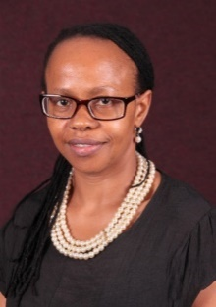 PROFESSOR THENJIWE MEYIWA

Professor Meyiwa is the Durban University of Technology’s Registrar and an honorary researcher at the Human Sciences Research Council. She is also an honorary professor with the University of KwaZulu-Natal’s School of Social Sciences. Meyiwa is a Fulbright and National Research Foundation (NRF) rated scholar, with extensive experience in higher education; as an administrator and a researcher. Her areas of research interest include cultural constructions of gender, contemporary human behavioural patterns, and the impact of HIV/AIDS on parenting, women and caregivers. She has more than 15 years’ experience of gender training, research and development and policy analysis, and has worked in South Africa and internationally with organisations and research teams including government organisations, universities and human rights NGOs. She is a member of various parastatals, community and civil society organisations, and is an Advisory Board member of the Rural Women’s Movements, as well as the Chairperson of the South African National Heraldry Council.
Within the above-listed subject fields and research interests, Meyiwa has successfully graduated numerous Masters & PhD students, presented conference papers at national and international forums, as well as published extensively.

Topic: Breaking the Glass Ceiling
(Ability and Leadership is Sexless: On Breaking the Glass Ceiling within the Higher Education Sector)
Presentation Overview:
Persuaded by Margaret Atwood‘s famous quote; “We still think of a powerful man as a born leader and a powerful woman as an anomaly”, I interrogate South Africa’s pool of well-educated women versus the reality that its higher education (HE) sector continues to be starved of women leaders. Significant rises in the number of women students at undergraduate level have not translated into comparative increases at postgraduate level or in management. This fact has broader social and economic implications; evidently, women continue to face discrimination and their skills and talent are blatantly ignored. In the context of challenges that are currently experienced within our HE sector, mainly the #Fees Must Fall Movement, leaders of the future will have to be visionary and should be real communicators – the ones that genuinely care. This skill is incredibly valuable and incredibly in demand. I argue that women’s potential to bring to leadership and executive positions the skill of being real communicators is greater than that of men.
It is crucial to ensure that women academics and higher education managers end up in senior positions by design than by accident - through conscious and deliberate programmes that ensures (not just encourage) that women opt a senior leadership career. I call upon a commitment to increasing the proportion of women in scholarly research and executive positions through recruitment, retention and promotion; towards breaking the glass ceiling within the higher education sector. Arguing that ability and leadership is sexless, I suggest several steps that could be taken to challenge male dominance and offer management training for women.

Peace Activist

ELA GANDHI
Born at the Phoenix settlement in Inanda South Africa, Ela Ghandi, granddaughter of iconic peace activist Mahatma Ghandi, attended the Durban Indian Girls High School, and thereafter the University of Natal non-European Section and obtained a BA (Social Science) degree.

Academic:
B.A. (Social Science) Honours (UNISA)
Conferred three Honorary Doctorates UKZN, DUT Siddharth University India

Professional:
Social worker in the child welfare field
Head of Information in Career Information field
Participated in CODESA negotiations as a representative of the Natal Indian Congress
Served on Transitional Executive Council.
Member of Parliament in the National Assembly 1994-2003- and served on the following committees:
- Social Development Portfolio Committee
- Portfolio Committee on Arts and Science
- Portfolio Committee on Justice and constitutional Development
- Portfolio Committee on Education
- Portfolio Committee on Public Enterprises
- Joint Standing Committee on Youth Children and People Living with Disability
- Joint Committee on Surrogate Motherhood
Presently retired.
Volunteer work:
Belonged to and was founder and executive member of:

Natal Organisation of Women (NOW) Treasurer and Vice Chairperson
Natal Indian Congress (NIC) vice chairperson and executive member
Detainees Support Committee (DESCOM), Chairperson and executive member
Children’s Rights Committee, Chairperson and executive member
Verulam Residents Association, Executive member
The Release Mandela Committee, Executive member
The United Democratic Front, Executive member in the Province and chair of the Region
Worker’s Support Committees, Executive member
Education Crisis Committee and member
Crisis Network for victims of violence and member

Also served on
African National Congress Women’s League as an executive member, Treasurer
African National Congress
South African Communist Party on the Central Committee

Presently serves in voluntary capacity as

Co-President of World Council on Religions for Peace International
Was Chancellor of Durban University of Technology –term ended in 2011 not renewed
Was Chairperson of Satyagraha and
Trustee of Gandhi Development Trust,
Member of African National Congress.
Member of International Centre of Nonviolence (ICON)
Council member of AMAFA and serve on other organisations as well
Chairperson of the Advisory Board of KAICIID

Topic: Gender Equity in Higher Education- Risk and Resilience: Fear of Failure
Presentation Overview:
History is important in both understanding the present context as well as planning for the future. Therefore, we have to be cognisant of the fact that our past was dominated by inequalities in terms of social, economic and gender biases.
Because of our strong policies in the past two decades, some changes have occurred at this level but attitudes are slower to change. Inequality in terms of access to jobs and positions is changing albeit not as rapidly as we would want to see it and not without the many problems embedded in change.
In this paper, I look at some of the problems faced by academics in the process of transformation from the apartheid system in which many of us grew up to the democratic dispensation that we are now seeking to establish, and to explore in this context three important elements:
- The change in the approach from a race, class and gender bias to an equity driven gender conscious and non-racial thought process;
- Change in the curriculum to reflect this new ethos; and
- Change in the composition in terms of the three inequalities- race class and gender.
In exploring these three elements, we need to analyse the effects of our past and then to see how we can impact the future to bring about the shift that is necessary for the transformation. Within this context, what is the role and position of women and what are the factors that negatively affect the development of a new ethos?
Finally, the need for courage and resilience to forge our way through the challenges and move forwards to overcome the difficulties.

Former Vice-Chancellor - University of the Witwatersrand (Wits) South Africa

PROFESSOR LOYISO NONGXA

Professor Loyiso G. Nongxa retired on 31 May 2013 as Vice-Chancellor and Principal of the University of the Witwatersrand (Wits), South Africa. He was born in rural South Africa in 1953. Prof Nongxa attended Healdtown High School; a school founded by the Methodist Church of Southern Africa in 1855. He attended the University Of Fort Hare from 1973 to 1978. In 1977, he became the first South African of African ancestry to be awarded the Rhodes scholarship and he went up to Balliol College, Oxford, in 1978. He lectured at the National University of Lesotho, the then University of Natal (now UKZN) and the University of the Western Cape where he was Professor of Mathematics from 1990 until 2000. He has served in various university leadership positions. During his 10-year term as Vice-Chancellor of the University of the Witwatersrand, the University had a special focus on broadening its African footprint through its Pan-African University Partnerships Initiative. Prof Nongxa returned to University of the Witwatersrand in May 2014 as the Founding Director of the Centre for Mathematical and Computational Sciences which will complement the activities of the DST/NRF Centre of Excellence for Mathematical and Statistical Sciences.

Topic: Innovation for Sustainability within Higher Education
Presentation Overview:
Financial sustainability is one of the key and major challenges facing higher education institutions throughout the world. Yet, it is a question that has not been addressed explicitly by the major stakeholders within the South African higher education system. Individual institutions might have grappled with this when developing institutional strategic plans, but we are not aware of any sectorial debate around what the concept means for the South African higher education system. We can define an institution to be financial sustainable if it has in place a comprehensive plan that provides it with (a) the financial strength to be competitive in the national and international higher education market, especially in attracting and retaining the best academic talent (students, academic and support staff), (b) the flexibility to be responsive to the ever-changing higher education landscape and take advantage of emerging opportunities, and (c) the resilience to withstand and face-up to the challenges and pressures during difficult times (economic, social, political, etc.) and mitigate the risks. Between 2008 and 2011, the European Universities Association embarked on a project under the theme; “The financial sustainability of Europe’s universities”. One of the main conclusions of the study is that future financial sustainability depends on reliable, sufficient public funding, and the autonomy and support necessary to explore successfully complementary funding options.

Head of International and Governance Relations – eThekwini Municipality

ERIC OSWALD APELGREN
Eric is currently responsible for all Durban’s sister city relationship, supporting bids to bring big sports as well as cultural events to Durban. He works with the Mayor and City Manager on all international relations, protocol and etiquette and provides strategic advice and support to all political office bearers and senior management on all matters relating to international relations, intergovernmental relations and protocol.

Senior Manager - Development, Kwa-Zulu Natal Tourism Authority, responsible for the facilitation and implementation of tourism related development projects in the province, with an emphasis on new tourism products, economic empowerment and inclusion of disadvantaged communities in new and existing tourism products.
Regional Director, KwaZulu Natal, Idasa - Institute for Democracy in South Africa, responsible for designing, managing and implementing programmes to promote democracy and a culture of human rights South Africa.
Regional Coordinator, KwaZulu Natal - Institute for Multi-Party Democracy (MPD), responsible for identifying opportunities for programme work to promote political tolerance and national reconciliation in South Africa, particularly among aspirant politicians, youth and rural communities, with a focus on involving women.
Development Officer, KwaZulu Natal - Catholic Archdiocese of Durban, responsible for identification, support and appraisal of urban and rural development projects benefiting poor communities in and around Durban. Also supporting community-based structures to facilitate development in areas experiencing high levels of violence, poverty and natural disasters. Managed all OXFAM –UK development funding in KwaZulu-Natal.
Secondary school teacher, Department of Education and Culture, teaching Geography and school guidance.
- Board member of Mfundoyesizwe trust - building schools in KZN
- Accredited Mediator on Land and Community disputes.
Founding member of the Wentworth Improvement Project – programme to empower youth and especially gangsters and youth in trouble with the law.

Topic: EThekwini Municipality – A municipal perspective on leadership strategies and challenges in the realisation of the vision to be Africa’s most caring and liveable city.
Presentation Overview:
Durban is a City on the east coast of Southern Africa with a diverse population of 3.6 million people. It is also home to about 200 000 migrants.
The eThekwini Municipality is a local government organisation that is a responsible for delivering services to all its citizens. The municipality is a sphere of government that is autonomous but also aligned with the provincial and national spheres. This alignment and integration has some successes but also has enormous challenges. The challenges and complexities of this alignment and integration are political and administrative in nature.
The City has an Integrated Development Plan that is the contract all officials and councillors have with the people of the city to deliver municipal services.
All officials have a service delivery /performance management agreement to ensure that quality services are delivered.
All wards have war rooms/Operation Sukuma Sakhe/ward committees that are chaired by ward councillors. OSS is a provincial campaign.
The city has a cluster form of economic development projects – developed in the form of catalytic projects. These projects are key to driving job creation opportunities and investment potential.

Urban Future Centre (DUT)
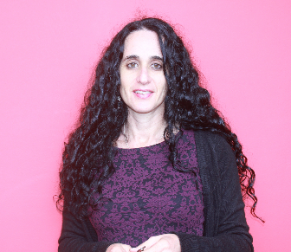 PROFESSOR MONIQUE MARKS
Prof. Monique Marks currently heads up the newly established Urban Futures Centre at the Durban University of Technology (UFC@DUT). Initially trained as a social worker, she has a doctorate in Sociology from the University of Natal, and writes predominantly in the field of criminology. She has published widely in the areas of youth social movements, ethnographic research methods, police labour relations, police organizational change and security governance. She has published five books: Young Warriors: Youth Identity, Politics and Violence in South Africa; Transforming the Robocops: Changing Police in South Africa; and Police Occupational Culture: New Debates and Directions (edited with Anne-Marie Singh and Megan O’Neill); The Spaces In Between; and Police Reform from the Bottom Up (edited with David Sklansky). She has also published over 47 peer reviewed articles and numerous reports. She sits on a number of journal editorial boards as well as the Board of Trustees of the Safer South Africa Foundation. Her research is mostly ethnographic and takes place in spaces that are considered compromising or unsafe.

Topic: Positioning Women in Leadership
(How to survive in a Hyper Masculine Space)
Presentation Overview:

While it is generally acknowledged that universities are ‘masculine spaces’, my ability to become a ‘leader’ has resulted less from my experience in challenging university structures, processes and personalities, than from opting to act in arenas that can best be described as ‘hyper masculine’. These include working closely with the police, often as an insider-outsider, with young people involved in acts of collective violence, and with the drug use community. These are generally groupings that are viewed as antithetical to the ‘feminine’. Finding ways of interacting, building trust and having impact in these contexts has without doubt provided me with the confidence and sense of self to take on leadership positions, and to wisely use professional (and street level) discretion. It has also taught me the importance of building relationships, across all barriers, which I believe to be critical to all good leadership. This is not to say that I do not feel myself to have many deficits as a leader in the university. I certainly do and these I will discuss openly.

Research Chair for Historical Trauma and Transformation
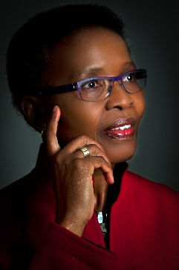PROFESSOR PUMLA – GOBODO MADIKIZELA
Pumla Gobodo-Madikizela is Research Chair for Historical Trauma and Transformation in the Faculty of Arts and Social Sciences, Stellenbosch University. Her previous positions are, Professor of Psychology at the University of Cape Town, and Senior Research Professor for trauma, memory and forgiveness at the University of the Free State. Her book, A Human Being Died that Night: A South African Story of Forgiveness won the Alan Paton Award in South Africa, and the Christopher Award in the United States for “a book that speaks to the human spirit.” The book has been published six times, including translations in Dutch, German and Italian. Her other books include Narrating our Healing: Perspectives on Healing Trauma, as co-author with Chris van der Merwe (2007), Memory, Narrative and Forgiveness: Perspectives on the Unfinished Journeys of the Past, as co-editor with Chris van der Merwe (2008), Breaking Intergenerational Cycles of Repetition: A Global Dialogue on Historical Trauma and Memory, as editor (2015), and A Reflexive Inquiry into Gender Research: Towards a New Paradigm of Knowledge Production, as co-editor with Samantha van Schalkwyk (2016). Her current book project is a monograph (as editor) that focuses on a close analysis of dialogue between adult children of Nazi perpetrators and descendants of Holocaust survivors. The monograph derives from her ongoing collaboration that she has been leading with German and Jewish-German psychotherapists and psychiatrist based in Cologne and Dusseldorf, and with colleagues at Cologne University.
She has co-edited three special issues: “Critical Psychology in Africa,” in Subjectivity: International Journal of Critical Psychology (2006), “Ethical Uncertainties in Psychoanalytic Practice and Research in Challenging Times” (2009), in the Psychoanalytic Psychotherapy in South Africa, (2009), and “Continuities and Transformation in the Aftermath of Conflict in Africa,” in Signs: Journal of Women in Culture and Society (2014).
Gobodo-Madikizela has delivered several endowed lectures and keynote addresses internationally on her research. Her honours include: being honoured among “100 People who Made a Difference” in the Permanent Exhibit of Hall of Heroes in the National Freedom Centre in Cincinnati, Ohio in the United States, 2005; the Eleanor Roosevelt Award, 2007; and the Social Change Award for “contribution made by leading psychologists in South Africa,” 2010. She was awarded the SARChI Chair for Historical Trauma and Memory (2015), and in the same year was awarded a five-year Andrew W. Mellon Foundation grant for the project “Trauma, Memory and Representations of the Past: Transforming Scholarship in the Humanities and the Arts.”
Gobodo-Madikizela was recently named the 2016 Distinguished African Scholar, which comes with a fellowship tenable at Cornell University. She has received various research fellowships in the past, including fellowships at the Harvard Radcliffe Institute for Advanced Study (1999 – 2000), the Carr Centre for Human Rights Policy at the Kennedy School at Harvard University (2000 – 2001), and the Claude Ake Visiting Chair in the Peace and Conflict Research Department at Uppsala University, Sweden (2015).

Topic: Ethics of Higher Education in Social Justice
(Empathy and the Ethics of Leadership)

This aspect of discussion is part of a larger NRF research project. The larger NRF Project is entitled: CE: Barriers and Drivers of Community Engagement in South African Higher Education. I am extremely grateful to the NRF for funding this project and supporting its continual development.

