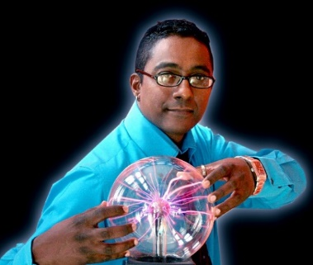
Megandhren Govender
20 Tipuana Place, Lotus Park, Isipingo, 4133, Durban, South Africa
Tel: 27 31 3732075 - Email: megandhreng@dut.ac.za
Mobile 27 83 4149698
Identity number: 7108295140085

Personal Profile

My career spans over twenty five years of academic, research and managerial experience in the teaching and administration of mathematics, applied mathematics and theoretical physics to scientists, engineers, chemists, biotechnologists, medical doctors, emergency personnel and food technologists at tertiary level. Focus areas include teaching of mathematics and applied mathematics to graduate students, supervision of Honours, MSc. And PhD students, mathematical modelling in relativistic astrophysics and mathematical cosmology, differential equations, mathematical modelling of problems in industry (optimisation of dynamical systems involving fluid mechanics, thermodynamics, classical mechanics and quantum systems). Internationally recognised astrophysicist with a collaborative network covering South Africa, India, Sri Lanka, Spain, UK, Mexico, Oman, Morroco, Italy and Venezuela. Excellent manager and supervisor over a range of cutting-edge projects and assignments. NRF-rated scientist with a C2 rating. Motivational speaker, screenwriter and author.

I have also taken science and mathematics to the masses in the form of my science road shows as well as presentations in theater. My shows which include “Riddles in Your Soup Mug”, “The Flying Circus of Science”, “The Science of Fun”, “So You Thougt Einsetin was a Genius” and “That Big Science Show” has been enjoyed by tens of thousands of learners, educators, academics, parents and the general public. The shows combine a unique take on science, math and elements from engineering and technology which sync with everyday applications. The demonstrations tie in beautifully with the school curriculum. I have performed these science shows for the better part of the past fifteen years.

1. Academic Qualifications

1995-1998 PhD, University of Natal.
1994-1994 MSc., Cum Laude, University of Natal. 1993-1993 BSc. Hons., First Class, University of Natal
1990-1992 BSc., Applied Maths and Physics, University of Natal.

2. Employment History

[1] 1994-1998 Part-time contract lecturer, Electrical Engineering,
Mangosuthu Technikon.
[2] 1996-1998 Contract lecturer, Physics, Technikon Natal.
[3] 1998-2000 Senior lecturer, Physics, Technikon Natal.

[4] 2000-2002 Head of Physics and Associate professor, Technikon Natal
[5] 2003 – 2015 Senior lecturer and researcher, School of Mathematics, UKZN
[6] 2015 – 2016 Associate Professor, Mathematics Department, Durban University
of Technology.
[7] 2016 – present Full Professor, Mathematics Department, Durban University
of Technology.

- Academic leadership

Technikon Natal

  - Key participant in the development of course material at undergraduate and postgraduate level. These courses include Physics for Radiographers, Food technologists, Biotechnologists, Analytical Chemists, Textile Science, Engineering, Maritime Studies, Paper Technology and Biomedical Science.
  - Played a pivotal role in management as head of department. Representations on Academic Board, Research Committee and chairman of the Academic Computer Committee.

University of KwaZulu Natal

  - Development of course material: math and applied math syllabi, tutorials, examinations, learning website, multimedia content and demonstrations.

  - Mentoring of new staff members both in the teaching and research ambits. Mentoring consisted of assisting new staff members with preparation of lectures, tests and examinations. Further assistance with the setting up of and administration of tutorials was also part of the mentoring and coaching program.
  - Collaborating with new staff members on research projects has led to fruitful solutions of fundamental problems in relativistic astrophysics. Co-supervision of Honours students with new staff members led to students successfully completing their MSc and Honours degrees.
  - External examiner for Math 356 (2016 – current)
  - External examiner for General Realtivity (Honours) (current)
  - External examiner for Honours projects. (current)

Durban University of Technology



Actively Involved in wider DUT community:
    - Member of Senate, Faculty Board, Faculty Research Committee, Institutional Research Committee, Higher Degrees Committee.
    - Presentation at Strat Plan Workshop, 2 December 2015, Pumula Beach Hotel.
    - Staff Strategy Session – Department of Math, DUT – 3 March 2016.
    - Staff Strategy Session – Department of Math, DUT – September 2018.
    - Actively involved in e-learning innovation.

 We are seeking to establish a research unit within the Department of Mathematics which will cover diverse areas in pure mathematics, applied mathematics, physics, mathematical biology and engineering. Some of our key strengths within our department include:

- Ordinary and partial differential equations and Lie analysis
- Graph theory
- Relativistic astrophysics
- Cosmology
- Extended irreversible thermodynamics
- Fluid mechanics
- Classical mechanics
- Quantum mechanics
- Philosophical foundations of quantum mechanics
- Maths education.
The aim of this research unit is to foster interdepartmental collaborations within DUT, establish collaborations with other research centres and institutes both locally and abroad.

Workshops

Organised and secured funding for:

- MATHEMATICS RESEARCH WORKSHOP, 24 – 26 November 2017, Drakensberg Sun
“Developing Research Streams in the Department of Mathematics”
- Mathematics, Research and Society Workshop, 30 November – 2 December 2018, Cathedral Peak Hotel, Drakensberg.

Recent Awards

- Researcher of the Year (2017) in the Department of Mathematics, DUT
- Awarded the Vice Chancellors award for Internationalisation of the University through my work on compact objects in general relativity, December 2018.

Professional

 Founding member of the Southern African Relativity Society.
 Member of the Astrophysics and Cosmology Research Unit, UKZN.
 Reviewer for the following research journals: (1) International Journal of Theoretical Physics, (2) International Journal of Modern Physics D, (3) General Relativity and Gravitation, (4) Journal of Gravity and (5) European Journal of Physics C.
 H-index = 21
- I10-index - 35
 Research Gate score: 31.44
 NRF reviewer for rated scientists.
 Member of the local organising committee: Hanno Rund Conference on Relativity and Thermodynamics, University of Natal, Durban, 1996.

- Secured and hosted the first international research workshop on gravitation, thermodynamics and cosmology (2001) at Technikon Natal.
 Member of the local organising committee: GR16, International conference on Gravitation, ICC, Durban, 2001.
 Served on the Standards Generating Board for Physics in Higher Education.
 Facilitator and trainer for the Department of Education (Physics).
 Plenary speaker at the Arya Samaj Conference (2012), City Hall, Durban South Africa. Invited by the South African Hindu Maha Sabha. (Title of presentation: Origins of the Universe.)
 Invited talk at the SKISA Annual Global Youth Focus Program 2012, Durban University of Technology. (Title of presentation: The Children of Today are the Leaders of Tomorrow.)
 Presentation at the Fifth Annual University Teaching and Learning Conference T-Block, Westville Campus, Durban, UKZN and Chair of session 3. (Title of presentation: Avoiding the “Solve for x” Syndrome in the Teaching of Applied Mathematics to Undergraduate Engineers.)
 Plenary speaker at the ASTRAZENECA “Connecting Experts in Diabetes” Forum, Lagoon Beach Hotel, Cape Town, October 2015. (Title of presentation: The Science of Fun)
 Plenary speaker at the 8th Annual CSI Matters conference, Wanderers, 5 – 6 May 2015. (Title of presentation: Innovative Thinking)
 Invited keynote speaker for 2016 Teaching and Learning Conference, DUT, November 2016.
 (Title of presentation: Will the Real Einstein please stand up?)
- Invited Keynote speaker: 3rd Interdisciplinary Research and Postgraduate Conference,
Coastlands Hotel, Musgrave, September 2018.
- Engineering Orientation, UKZN – Subject advice to first year students, 29 January 2019.
- Invited Keynote speaker: 4th Interdisciplinary Research and Postgraduate Conference,
Hilton Hotel, Durban, September 2019.
- Presentation at Faculty Research Day, 2019, Probing Higher Dimensions with Modified Theories of Gravity,
Maharani Hotel, November 2019.

Teaching and Supervision

 Successful completion of Induction Course: CELT, DUT.
 Lectured S1 Mathematics to Engineering students.
 S2 mathematics moderator.
 S3 mathematics examiner.
 Excellent student evaluations – consistent AVERAGE RATING 1.3 to 1.7 (green)
 Active departmental participant in recurriculation of Math syllabi and student study guides for B. Eng. Programmes.

SUPERVISION OF POSTGRADUATE STUDENTS
Student name | - Year |  | - Degree | - Role | Status
- [1] Miss Nolene Naidu | • | 2008 | - MSc. | - Co-supervisor | - Graduated (Cum Laude)
- [2] Dr Gabriel Govender | • | 2009 | - PhD | - Mentor and research collaborator | - Graduated
- [3] Mr Darryl Fleming | • | 2011 | - MSc. | - Supervisor | - Graduated (Cum Laude)
- [4] Mr L Mkhize | • | 2012 | - Hons. | - Supervisor | - Graduated
- [5] Mr L Mkhize | • | 2013 | - MSc | - Supervisor | - Graduated
- [6] Mr V Zitha | • | 2013 | - Hons. | - Supervisor | - Graduated
- [7]Mr K P Reddy | • | 2013 | - PhD | - Supervisor | Graduated
- [8] Mr R Bogadi | • | 2013 | - PhD | - Supervisor | - Graduated (2017)

[16] Mr W Govender  - [9] Mr V Zitha • 2014 - MSc - Co-supervisor Graduated  - [10] Mr A Ntshangase • 2014 - MSc - Supervisor Graduated  - [11] Miss N Naidu • 2014 - PhD - Supervisor - Graduated (2018)  - [12] Mr V Zitha • 2015 - PhD - Co-supervisor - Graduated (2019)  - [13] Mr M A D Ntshangase • 2015 - PhD - Supervisor - Current  - [14] Mr A Kaisevelu • 2016 - PhD - Supervisor Completed (2020)  - [15] Mrs N Mewelall • 2016 - PhD - Co-supervisor - Graduated (2019) | 2018 | PhD | Co-supervisor | Submitted (2021)
[17] Mr L W Mbjanwa | 2018 | PhD | Co-supervisor | current

EXAMINATION OF MASTERS and DOCTORAL DISSERTATIONS
Qualification | Year | Student | Title of thesis | Institution
[1] MSc | 2011 | Mr Sifiso Allan Ngubelanga | Exact Solutions for Relativistic Models | School of Math, UKZN
[2] PhD | 2011 | Mr A Msomi | Applications of Lie Symmetries to gravitating fluids | School of Math, UKZN
[3] MSc | 2012 | Mr M N Mahlatji | Some Models of Relativistic Radiating Stars | School of Math, UKZN
[4] PhD | 2014 | Mr Sifiso Allan Ngubelanga | Models in Isotropic Coordinates and an equation of state | School of Math, UKZN
[5] MSc | 2014 | Mr Byron Brassels | Shear-free models for relativistic fluids with heat flow and pressure isotropy | School of Computer Science, Math and Stats, UKZN
[6] M. Tech. | 2015 | Mr SA Mars-Brown | A comparative study, with controls, of the NMR spectra of Sulphur 12CHprepared using Hannemannian method | Department of Homoeopathy, DUT
[7] M. Tech. | 2015 | Ms. D Naicker | An Ontological analysis of the visual expression of water-based homoeopathic remedy, Natrum muriaticum, as droplet glass stain patterns | Department of Homoeopathy, DUT
[8] PhD | 2016 | SUBODH SHRIDHARRAO DESHPANDE | MATHEMATICAL MODELING IN BIOMECHANICS OF SPORTS | Department of Math, Nagpur University

Qualification | Year | Student | Title of Dissertation | Institution
[9] MSc | 2017 | Mr L Mbanjwa | Exact Solutions for Static Fluid Distribution with Isotropic Pressure and Equation of State | School of Mathematics, UKZN
[10] MSc | 2017 | Mr W Govender | Analytical Solutions for Non- adiabatic relativistic fluids with pressure isotropy and equations of state". | School of Mathematics, UKZN
[11] MSc | 2018 | Mr N Mkhize | Exact Solutions for perfect fluids in trace -Free Einstein gravity | School of Mathematics, UKZN
[12] PhD | 2018 | Mr S Mlaba | Charged fluid spheres in Einstein and modified gravity theory. | School of Mathematics, UKZN
[13] PhD | 2018 | Mr D Kileba Matondo | New Families of Exact Solutions for Compact Stars | School of Mathematics, UKZN
[14] MSc | 2019 | Miss Kathleen A. Sellick | Some Aspects of strong gravity effects on the electromagnetic field of a radio pulsar magnetosphere: solving the Maxwell’s equations | School of Mathematics, UKZN
[15] MSc | 2019 | Miss Nomfundo Gabuza | Exact Solutions in Pure Lovelock Gravity | School of Mathematics, UKZN
[16] MSc | 2020 | Mr Lushen Moodly | Hyperspheres of Static Charged Fluids in Standard and Modified Gravity | School of Mathematics, UKZN

Research Outputs

  - > Sixty international research papers in Mathematics and Physics research journals. Many of these papers represented ground-breaking work which opened up new research areas in relativistic astrophysics and extended irreversible thermodynamics in curved spacetime.
  - Research work presented in India, Brazil, UK, USA and Australia.
  - Attended various conferences and workshops in Mathematics, Physics, Astrophysics, Cosmology and Education both locally and abroad.
  - NRF-rated researcher (C2 rating 2016).

RESEARCH OUTPUTS 2021

- Pant, N., Govender, M. and Gedela S., A new class of viable and exact solutions of EFE's with Karmarkar conditions: An application to cold star modeling, Res. Astron. Astrophys., in press.
- Hansraj, S., Govender, M. Banerjee, A. and Mkhize, N., All Conformally Flat Einstein-Gauss-Bonnet static Metrics, Class. Quantum Grav., in press.
- Thirukkanesh, S., Bogadi, R., Govender, M. and Moyo, S., Stability and improved physical characteristics of relativistic compact objects arising from the quadratic term, Eur. Phys. J. C, 81:1.
- M. Govender, K. P. Reddy, W. Govender and S. D. Maharaj, A perturbative approach to the time-dependent Karmarkar condition, Eur. Phys. J. C, in press.

RESEARCH OUTPUTS 2020

- Bogadi, R. S., Govender, M. and Moyo, S., Dynamical (in)stability analysis of a radiating star model, cast from an initial static configuration, Euro. Phys. J. Plus, (2020) 135:170.
- Sharma, R, Das, S., Govender, M. and Pandya, D. M., Revisiting Vaidya-Tikekar Stellar model in the linear regime, (2020), 414:168079..
- M. Govender, A. Maharaj, Ksh. Newton Singh and N. Pant, Dissipative collapse of a Karmarkar star, Modern Physics Letters A, (2020), 10: 2050164.
- S. Thirukkanesh, A. Kaisavelu and M. Govender, A Comparative Study of the Linear and Colour-flavoured-locked equation of states for compact objects, European Physical Journal C, 80, 214.
- N. F. Naidu, R. S. Bogadi, A. Kaisavelu and M. Govender, Stability and horizon formation during dissipative collapse, General Relativity and Gravitation, 52, 79.
- R. S. Bogadi, M. Govender and S. Moyo, Surface tension of strange stars mediated by a color-flavor-locked equation of state, Physical Review D, 102, 043026.
- A. Kaisavelu, S. Thirukkanesh, M. Govender and S. D. Maharaj, Annals of Physics, 419, 168215.

RESEARCH OUTPUTS 2019

- Govender, M., Mewelal, N. and Hansraj, S, The role of an equation of state in the dynamical (in)stability of a radiating star, Eur. Phys. J. C (2019) 79: 24.
- Bhar, P and Govender M., Charged Compact Star in Einstein-Maxwell-Gauss- Bonnet Gravity, Astrophys, Space Sci. (2019) 364:186.

RESEARCH OUTPUTS 2018

- Naidu, N. F., Govender, M. and Maharaj, S. D. Radiating star with a time-dependent Karmarkar condition, European Physical Journal C, 78, 48 (2018)
- Govender, M., Maharaj, A., Lortan, D. B. and Day, D. Temperature evolution in the presence of anisotropic stresses, Astrophys. Space Sci., 363, 165 (2018)
- Hansraj S., Govender, M. and Mewelal, N., Expanding, shearing and accelerating isotropic plane symmetric universe with conformal Kasner Geometry Modern Physics Lett. A, 33, 25 (2018)

RESEARCH OUTPUTS 2017

1. Naidu, N. F.; Govender, M.; Thirukkanesh, S.; Maharaj, S. D., Radiating fluid sphere immersed in an anisotropic atmosphere ,Gen. Relativ. Gravit. 49, .95, 12 (2017)
2. Maurya, S. K.; Ratanpal, B. S.; Govender, M., Anisotropic stars for spherically symmetric spacetimes satisfying the Karmarkar condition, Annals of Phys., 382, 36 (2017)
3. Maurya, S. K.; Govender, M., A family of charged compact objects with anisotropic pressure, EPJC, 77, .420 (2017)
4. Maurya, S. K.; Govender, M., Generating physically realizable stellar structures via embedding, EPJC, 77, 347 (2017)
5 Bhar, Piyali; Govender, Megan; Sharma, Ranjan, A comparative study between EGB gravity and GTR by modeling compact stars, EPJC, 77, 109 (2017)
6. Newton Singh, Ksh.; Pant, Neeraj; Govender, M., Anisotropic compact stars in Karmarkar spacetime, Chinese Phys. J., 015103 (2017)
7 Govender, M.; Bogadi, R. S.; Maharaj, S. D., The influence of an equation-of-state during radiative collapse, IJMPD, 26, 1750065 (2017)
8. Bhar, Piyali; Govender, Megan, Anisotropic charged compact star of embedding class I, IJMPD, 26, 1750053 (2017).
9. Bhar, P, Govender, M and Sharma R, Modeling Anisotropic Stars Obeying Chaplygin Equation of State, Pramana J. Phys. (2017)
10. Maharaj A, Lortan DB & Govender M (2017) Symmetry Properties of a Novel Riccati Sequence PONTE: International Journal of Science and Research.

RESEARCH OUTPUTS 2015/2016

- Naidu, N. F. and Govender, M. (2016). The Influence of Initial Conditions during Dissipative Collapse, International Journal of Modern Physics – D, 25(10), 16500929.
- Singh, N., Pant, N. and Govender, M. (2016). Some Analytical Models of Relativistic Compact Stars, Indian Journal of Physics, 90(11), 1215.
- Govender, M., Bogadi, R. S., Lortan, D. B. and Maharaj, S. D. (2016). Radiating collapse in the presence of anisotropic stresses, International Journal of Modern Physics – D, 25(3), 1650037.
- Banerjee, A., Rahaman, F., Islam, S. and Govender, M. (2016). Braneworld gravastars admitting conformal motion, European Physical Journal – C, 76, 34.
- Govender, M., Bogadi, R. S., Das, S. and Sharma, R. (2016). Gravitational collapse in spatially isotropic coordinates, Astrophysics and Space Science, 361, 33.
- Govender M., Maharaj, S. D., Lortan, D. B. and Mkhize, L. (2016). Thermal Evolution of the Kramer Radiating Star, Pramana – Journal of Physics, 86(1), 49.(9)
- Thirukkanesh, S., Govender M. and Lortan, D. B. (2015). Spherically symmetric static matter configurations with vanishing radial pressure, International Journal of Modern Physics - D, 24, 1550002.
- Govender, M. and Thirukkanesh, S. (2015). Anisotropic static spheres with linear equation of state in isotropic coordinates, Astrophysics and Space Science, 358, 16.
- Reddy, K. P., Govender, M. and Maharaj, S. D. (2015). Impact of anisotropic stresses during dissipative gravitational collapse, General Relativity and Gravitation, 47, 35.

RESEARCH PAPERS UNDER REVIEW

- Maharaj, S. D., Vusi, Z., Govender, M. and Tiwari, A., Expansion-free Collapse: An exact model, EPJC (2020).
- Hansraj, S., Govender, M., Moodly, L. and Singh, Newton, Superdense Star in 5-D Einstein-Gauss Bonnet Gravity, Annals of Phys. (2020).

RESEARCH OUTPUTS 2014 and earlier

[1] M Govender, K P Reddy and S D Maharaj, The Role of Shear in Dissipative Gravitational Collapse, IJMP-D, 23, 1450013 (2014).

[2] M Govender and S Thirukkanesh, Causal Heat Flow in Bianchi type-V Universe, MPLA, 29, 1450071, (2014).

[3] S. Thirukkanesh and M Govender, The Role of the Electromagnetic Field in Dissipative Collapse, IJMPD, 22, 1350087 (2013).

[4] M Govender, Nonadiabatic Spherical Collapse with a Two-Fluid Atmosphere, IJMPD, 22, 1350049 (2013).

[5] S D Maharaj, G Govender and M Govender, Radiating Stars with generalized Vaidya atmospheres, Gen. Relativ. Grav., 44, 1089 (2012).

[6] K S Govinder and M Govender, A general class of Euclidean Stars, Gen. Relativ. Grav., 44, 147 (2012).

[7] M Govender, K S Govinder and D Fleming, The Role of Pressure During Shearing, Dissipative Collapse, Int. J. Theoret. Phys., 51, 3399 (2012).

[8] S D Maharaj, G Govender and M Govender, to appear, Pramana – J. Phys.,
Proceedings of the Chandra Session, SAMS 53rd Annual Congress, South Africa (2011).*

[9] G Govender, M Govender and K S Govinder, Thermal behaviour of Euclidean stars, IJMP-D, 19, 1773-1782 (2010).*

[10] M Govender and S Thirukannesh, Dissipative collapse in the presence of Λ, J. Theoret. Phys., 48, 3558 (2009).

[11] N F Naidu and M Govender, Causal temperature profiles in horizon-free collapse, J. Astrophys. Astr., 28,
167-174 (2007).*

[12] N F Naidu, M Govender and K S Govinder, Thermal Evolution of a radiating anisotropic star, IJMP-D, 15,
1053-1065 (2006).*

[13] S D Maharaj and M Govender, Radiating collapse with vanishing Weyl stresses, IJMP-D, 14, 667-676 (2005).**

[14] S D Maharaj and M Govender, On radiating stellar models, ICGC proceedings, Jaipur, India (2005).

[15] M Govender and K S Govinder, Generalised Isothermal Universes, IJTP, 43, 2253-2262 (2004).**

[16] M Govender and K S Govinder, On a general framework for generating nonstatic solutions to the Einstein field equations, Gen. Rel. Grav., 36, 1265-1278 (2004).***

[17] M Govender, K S Govinder, S D Maharaj, R Sharma, S M Mukherjee and T K Dey, Radiating spherical collapse with heat flow, IJMP-D, 12, 667-676 ( 2003).*

[18] K S Govinder and M Govender, Comment “Time-dependent solution for a star immersed in a background radiation field, JMP, 44, 4868 (2003).****

[19] K S Govinder and M Govender, Collapse of a null string-fluid distribution,Phys. Rev. D, 68, 024034-1 – 024034-6 (2003).

[20] M Govender and N K Dadhich, Collapse on the brane radiates, Physics Letters B538, 233-238 (2002).****

[21] M Govender and K S Govinder, Temperature profiles of relativistic compact stars, IJTP, 41, 1979 (2002).*

[22] M Govender and K S Govinder, Causal heat transport in inhomogeneous Cosmologies, Gen. Rel. Grav., 33,
2015 (2002).

[23]K S Govinder and M Govender, Causal solutions in radiating gravitational collapse, Phys. Lett. A , 283,
71-79 (2001).**

[24] S M Wagh, M Govender, K S Govinder, S D Maharaj, P S Muktibodh and M Moodley,
Shear-free spherically symmetric spacetimes with an equation of state p = , Class. Quantum Grav.,
18, 2147-2162 (2001).***

[25] M Govender and S D Maharaj, Gravitational collapse of a charged radiating star with shear, Pramana – J. Phys.,
54, 715-727 (2000).***

[26] M Govender, R Maartens and S D Maharaj, Relaxational Effects in radiating stellar collapse, MNRAS, 310,
557-564 (1999).**

[27] R Maartens, M Govender and S D Maharaj, Inflation with causal heat flux, Gen. Rel. Grav., 31, 815 (1999).

[28] M Govender, R Maartens and S D Maharaj, A causal model of radiating stellar collapse, Class. Quantum Grav.,
15, 323-330 ( 1998).**

[29] Kesh S. Govinder, Megan Govender and Roy Maartens, On radiating stellar collapse with shear, MNRAS,
299, 809-810 (1998).****

[30] S D Maharaj and M Govender, Behaviour of the Kramer radiating star, Austr. J Phys., 50, 959-965 (1997).****

Community Engagement

[1] ACRU and School of Agriculture, Engineering and Science community outreach team member. The aim is to promote the School of Mathematics and the College to the larger public, especially potential engineering and science students. This involves presentations at National Science Week, Be a Scientist week, Engineering Winter School, Open Day, ACRU career week and supervision of school learners for work experience (2002 – present).

[2] Since 2006, we created the Dr G (Megandhren Govender) persona with the view of taking mathematics and physics to the masses. The aim was to show people (learners, educators, graduate students, corporate workers, lay person) that maths and science can be cool and exciting. We accomplished this with the clever use of innovative demonstrations, experiments, live shows, media presentations and live lectures. This innovative approach to teaching and learning has received rave reviews and support from the media, department of education, schools and the general public.

2020 Outreach

[1] Science presentation at St Mary’s Monastery, Marianhill. Invitation from Sister Agnes to address children and parents on the connection between Math and Science, 9 February 2020.

[2] Presentation to Math Teachers – some thoughts on Calculus, invited talk at Sastri College, 10 February 2020.

[3] Presentation to primary school teachers and HOD’s at Glenwood High School, invited by the headmistress, Dr A Barnes, 11 February 2020.

[4] Teaching mathematics during the COVID lockdown. Invited talk (via ZOOM) to teachers representing 180 schools in the Durban-Umlazi area, 17 August 2020.

2021 Outreach

[1] Presenting the 2021 Mathematics teaching plan for grades 10-12 educators via ZOOM, 8 February 2021 with Maths and Physics subject advisor, Mr Daniel Kruppanand. 145 schools were present.

- Grants and Awards

Astroparticle Collaboration – NRF funded, grant number RH81

Principle collaborators: Prof. S D Maharaj, Prof. K S Govinder and Dr M Govender Project title: Relativistic Stars
Funding obtained:

2008 = R113,600

2009 = R143,600

2010 = R170,000

2011 = R143,600

2016 – 2020 = R110000 to date (Incentive funding for rated researchers)

2017 = R60000 (DUT Research Office)

2018 =R90000 (DUT Research Office)

 Collaborator on the National Research Foundation (NRF) and Department of Science and Technology (DST) aided South Africa-India bilateral research grant worth R300 000 for the South African side for 3 years (2009- 2012). Project leader: Prof S D Maharaj.
 C2 rating obtained in December 2016.
 Winner of the Bronze Medal for the Advancement of Science in South Africa and the Henry Dyer Award.

Work ethic and Philosophy

When it comes to problem-solving, I subscribe to the following very simple philosophical principle first articulated by Albert Einstein:

The world we have made as a result of the level of thinking we have done thus far creates problems we cannot solve at the same level of thinking at which we created them.

I believe very strongly in performing at my best at all times, irrespective of the level of application. I am a hard worker who demands the best from myself and my team members, yet at the same time maintaining a pleasant working environment. Coupled with honesty and integrity, my performances have always been optimal, energetic and focussed.

POPULARISING MATHEMATICS and PHYSICAL SCIENCE

I have been presenting science shows nd public talks for the past fifteen years. I conceptualized the science road show after hosting the science club for grades 1 to 7 learners at the Univerity of KwaZulu Natal for many years. I realized that not all learners could transport themselves to the University on a Saturday morning so I decided to take the science show to the learners at their schools. The shows quickly became a feature at many primary and high schools around Durban with some schools making it an annual event at their schools. Spin off from these shows were

[1] Invitations to present at Science Expos which included many rural areas across KZN.
[2] Presentations at educator workshops. Teachers were taught how to link the theory and conceptual aspects of physical science to the world around us.
[3] Public outreach talks and demonsrations at Women’s day Celebrations, Opening of Science Laboratories, Violenec against women and children campaigns, Parent Eveings, School Awards Ceremonies, Public Talks and Demonstrations (Science Show Off), Theatre Shows at the Playhouse theatre in Durban and iZulu Theatre, Sibaya, Mayor’s Science Engagement Initiatives, Team Building Meetings for Corporates such as First National Bank.
[4] I have also been fortunate enough to enage with the media including television appearances on Eastern Mosaic, Mela as well as radio: ECR and Radio Lotus FM and numerous printed media.
[5] I have my own YouTube channel (What the Watt Science), Tik Tok channel (cool_science_guy)

THE Dr G Effect

In 2010 I wrote to Ellen of the popular Ellen DeGeneres show. My letter featured on her show and the Dr G persona was born. I have been performing science shows as Dr G. The Dr G shows included exciting, jaw-dropping experiments, elements of dance and music as well as motivation and inspiration. I have engaged with the public through Facebook, Instagram, Twitter and my own webpages and blogs: www.brokeassbillionaire.co.za and www.drgacademy.co.za.

I have also authored a book of science experiments which is hugely popular amongst school learners.

2020 – Dr G returns to theatre as the ROCKET MAN!

I am excited about returning to the Playhouse theatre with my brand new science show called THE ROCKET MAN. I am currently writing the script, working on the experiments, dance routines and of course training for what is going to be an amazing show which will combine science and mathematics in a never been seen before show. The show will debut in August 2020 and will consist of ten performances at the Durban Playhouse. School learners will attend during the week and there will be two performances for the general public.

Rocket Man brings together almost two and a half decades of my work in academia as well as my love for dance, music, acting and coaching. The experiments are going to be bigger and bolder.

WHAT PEOPLE HAVE TO SAY ABOUT Dr G

I have known Prof Govender for many years, not as the brilliant scientist that he is but as a committed edutainer who is able to enthuse people about physics. He is one of the few researchers who is not only a dedicated physicist, but who is also somebody who is able to communicate his passion for physics to the public.

For years I have watched him excite thousands of people of all ages about science. Whenever he performs one of his famous science shows, learners flock to him afterwards to ask about how to send plastic bottles into space or if it was a real light bulb that he dipped into liquid nitrogen.

He is always available to promote science every year during National Science Week. Even though he could not make it this year he is still an integral part of our big “Science Show Off” at UKZN. Here he joins forces with Ajay Bissessur from Chemistry and myself to excite as “Dr G” – not only young people but also those who think science is not for them.

“Dr G” even made it onto stage at the Playhouse and Sibaya Casino with his own shows, “So you thought Einstein was a Genius” and “So you thought Einstein was a Genius Too”. Once again he showed his great ability to make science accessible for everybody.

Dr. Tanja Reinhardt
Science Centre Coordinator, Science and Technology Education Centre, University of KwaZulu-Natal(STEC@UKZN)

“Dr G has visited our school, Crawford Prep La Lucia on numerous occasions and all these visits have been fantastic and thoroughly enjoyed by the pupils. The only complaint being that the time goes by far too quickly when he educates and entertains us. A number of our teachers have used many of the experiments done by Dr G to assist them with the teaching of the concepts in class or have encouraged the pupils to go and do more research on these topics. Some of our pupils have even used his ideas as a subject for their Science Fair Tasks e.g. Levitation and Elephant Toothpaste.”
Dan Henry, Science Mathematics Department, Crawford Preparatory, La Lucia

“What I remember the most about your inspiring science demonstrations at our school is the faces of the learners. They were always bright-eyed and filled with excitement. Your intriguing experiments and dialogue encouraged them to be curious about the science around them. You answered all of their questions and left them wanting to find out more. Your enthusiasm and knowledge has always inspired me as a teacher.”
Nadia Buttignon, educator, Atholl Heights Primary School.

“Dr ‘G’, aka Megan Govender, brings the WOW to science. Through his thrilling, fun and hands-on experiments, he encourages children to question and think for themselves - to discover the wonders of unfettered learning through experimentation.”
Dr Sally Frost, College PRM: Science, Agriculture & Engineering.

“For the average university student, the perception of the sciences is governed predominantly by the terms “messy equations” and “headaches” until we find someone who isn’t afraid to bring liquid nitrogen to class, perhaps with one or two vegetables tagging along. Someone who does not only encourage his students to look at the world from different dimensions , but to express their feelings towards maths, on his office wall, by nothing less than pink spray paint. This is what marks Dr G’s unconventional brilliance: a sense of madness which re-awakens one’s sense of wide-eyed wonder towards the world of physics.”
Viveka Tugh, Engineering student with an abstract sense of quirkiness.

“Concretising the abstract continues to be an enduring challenge for both teachers and learners of science. Dr G’s science demonstrations are an intersection of art and science; cemented by absolute ingenuity. Based on science taught at school level, the science demonstrations clarifies and escalates concepts beyond the drudgery of classroom walls providing a renewed and exciting way to understand everyday science. Enticing learners to think, to extend their imagination and most of all to awaken a love for science, is accomplished in a fun way. Seeing eyes light up, expressions of awe and smiles on both the young and old is a confirmation of the power of inspiration in education. Dr G’s demonstrations are magic which is simply science personified. My personal role model, Dr G exemplifies the contemporary scientist: ordinary, humble, passionate, hardworking and young – an ideal the youth can both identify with and inspire to become. ‘Genius – Dr G’s Awesome Science Demonstrations’ is a must read for all ages and persuasions.”
Krishnie Naidoo, Mathematics, Science, Technology and ICT
KwaZulu-Natal Department of Education.

OUTREACH

Prof. Govender has presented shows, talks and invited lectures at numerous schools in KwaZulu Natal, some of which include

- Glenwood Boy’s High School -
- Sastri College – facebook.com/sastricollege drg
- Strelitzia Secondary
- Danville Park Girls’ High School
- Ganges Secondary
- Hillcrest High School
- Star College
- Bechet High School
- Bonela High School
- Futura High School (Inter-House Math Quiz) – facebook.com/futurahigh.
- Eastbury Secondary
- Umkomaas Secondary School
- Grosvenor Girls’ High School

PRIMARY SCHOOLS

- Penzance Primary School (Centenary Celebrations – 2020)
- Chelsea Primary School
- Crawford La Lucia
- Glenmore Primary School
- Gordon Girls’ Primary School
- Atholl Heights Primary School
- Pinetown Senior Primary School
- Yellowwood Park Primary School
- Darnall Primary School
- Umkomaas Primary School
- Woodview Primary School
- Pelham Primary School
- Westville Junior Primary School

Media Links

- https://www.iol.co.za/ios/news/passionate-professor-dr-g-to-stir-parents-and-pupils-17187615 (show for the public, including motivational talks on excelling at exams.)
- https://risingsunchatsworth.co.za/134023/krish-swamivels-dance-school-celebrates-29-years-cultural-treasures/ (I was humbled by this collaboration of fusing dance, music and science on stage with a multitude of dancers, singers and entertainers.)
- https://www.dut.ac.za/dr-govender-is-the-first-full-professor-in-the-department-of-mathematics-at-dut/ (My inauguration was different – that’s putting it mildly).
- https://www.conferencespeakers.co.za/professor-megandhren-govender/
- https://www.timeslive.co.za/sunday-times/lifestyle/2010-04-25-science-joker-gets-ellen-talking/ (This was the article that launched the Dr G persona in South Africa).
- https://www.dut.ac.za/dut-gender-forums-cellc-take-a-girl-child-to-work-benefits-30-learners/ ( I always look forward to this annual presentation at DUT. It is great to see the enthusiasm and excitement shown by our young women towards science and math).
- https://www.youtube.com/watch?v=Tawu0AkU-zg
- https://www.meetup.com/Durban-Freethinkers/events/257855769/ (Simply an educational excursion of the mind. A beautiful presentation to open-minded people with far-reaching philosophies and beliefs including flat-earthers.
- https://bereamail.co.za/151425/riddles-in-your-soup-mug/
- https://www.dut.ac.za/lta-symposium/ (one of my favourite presentations. Science, research and fun at the postgraduate level).
- http://enewsletter.ukzn.ac.za/Story.aspx?id=112&storyid=1434 (One from the vault – encouraging the larger university community to recognise the synergy between theatre, math and physics.)
- https://www.mediaupdate.co.za/publicity/70038/the-willowton-group-sponsors-maths-and-science-kits-for-schools-in-kwazulu-natal (invited presentation to a host of sponsors, educators, councillors – worthy cause to provide science kits to schools).
- https://www.youtube.com/channel/UC2cfpZqwWPs_rwMiJzx6rjQ (My YouTube Channel!)
- https://www.youtube.com/watch?v=vrDgdi3idYo (The Ellen Feature on the Ellen DeGeneres Show – Ellen thinks I am female!)
The Science of Fun with Dr G!!!!

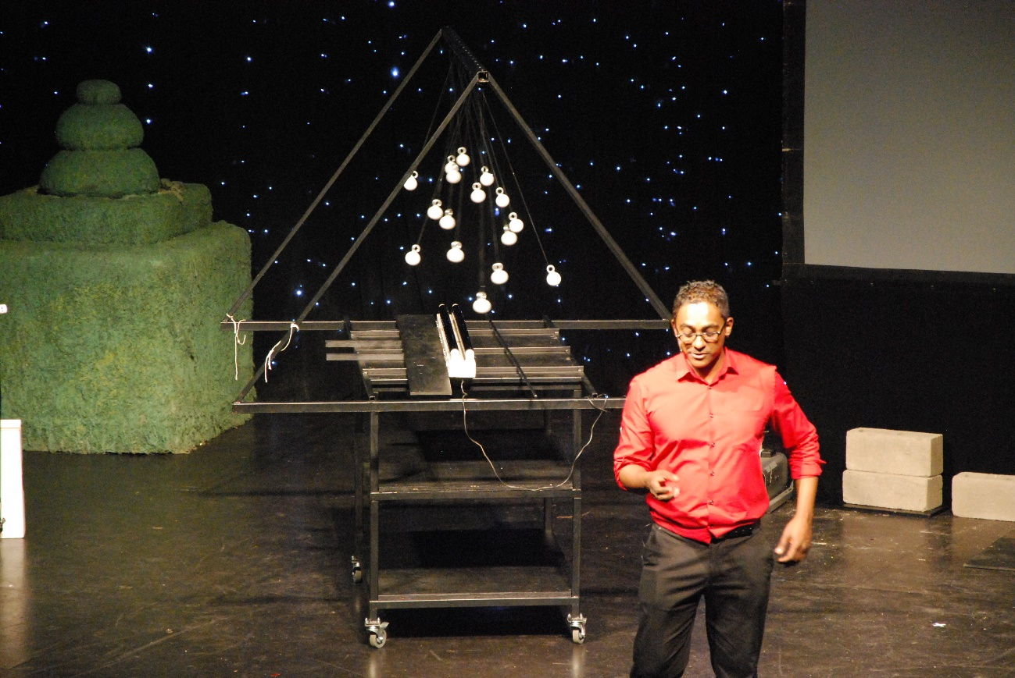

Harmonic Pendulum

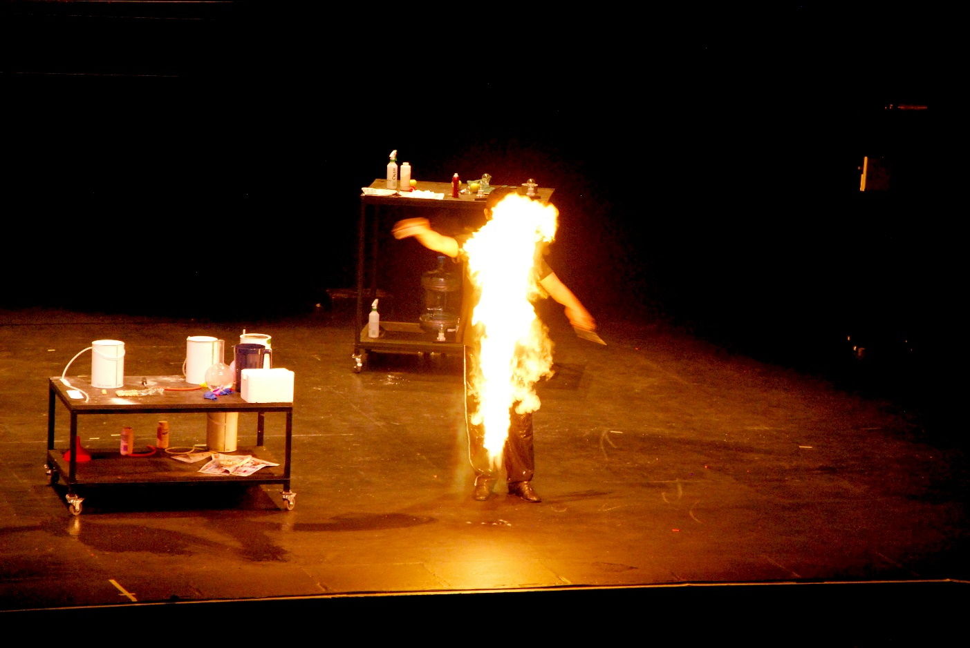

Lycopodium Powder

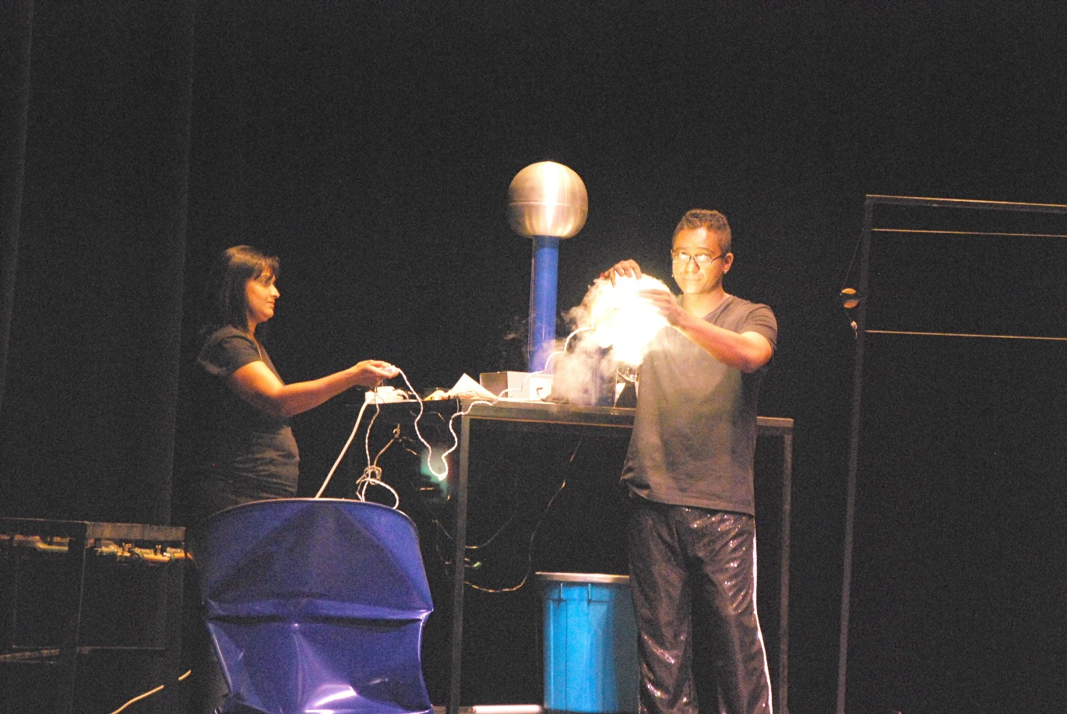

Light bulb in liquid nitrogen

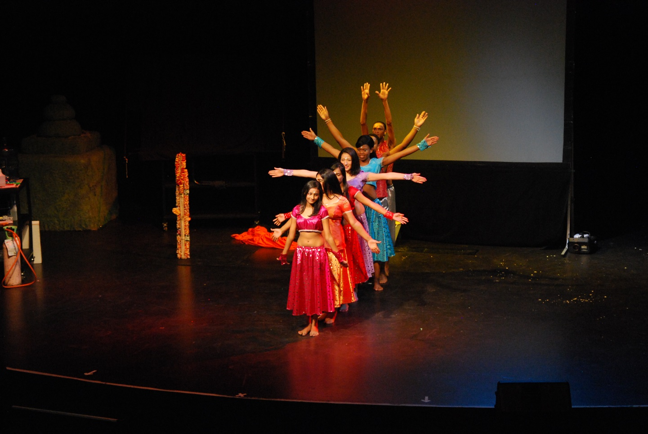

Music, symmetry and physics

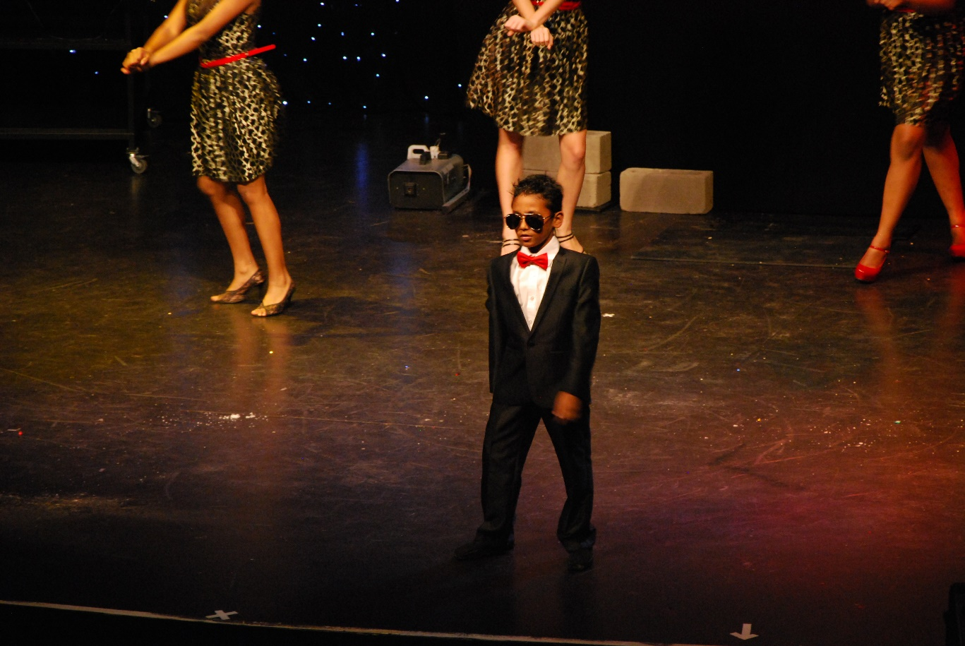

Dance and the laws of mechanics

Sleeping on a bed of nails!

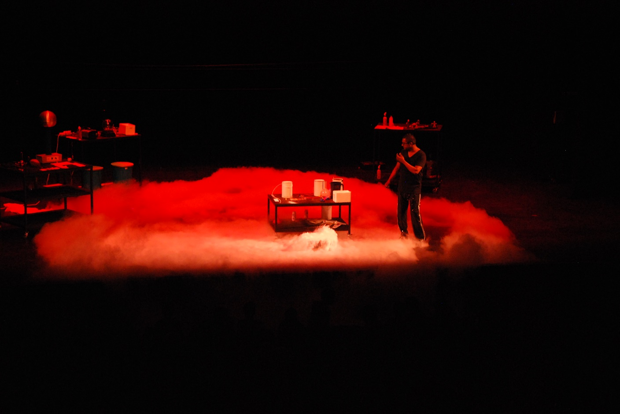
Clouds with liquid nitrogen

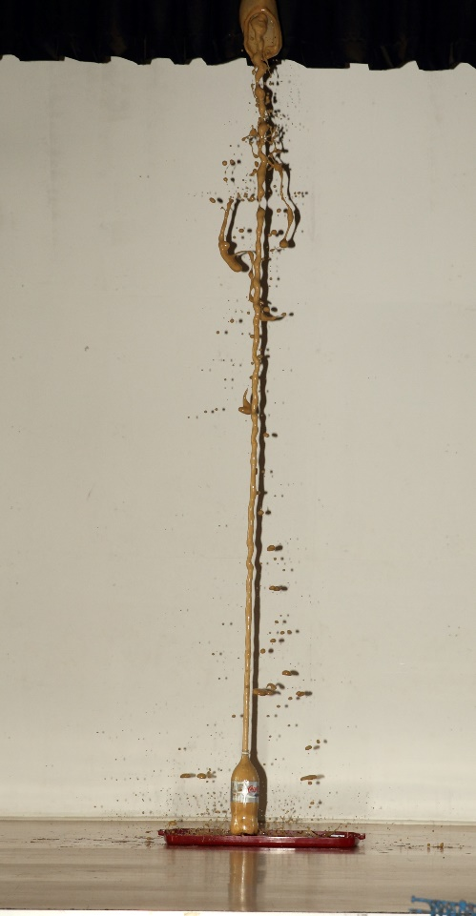
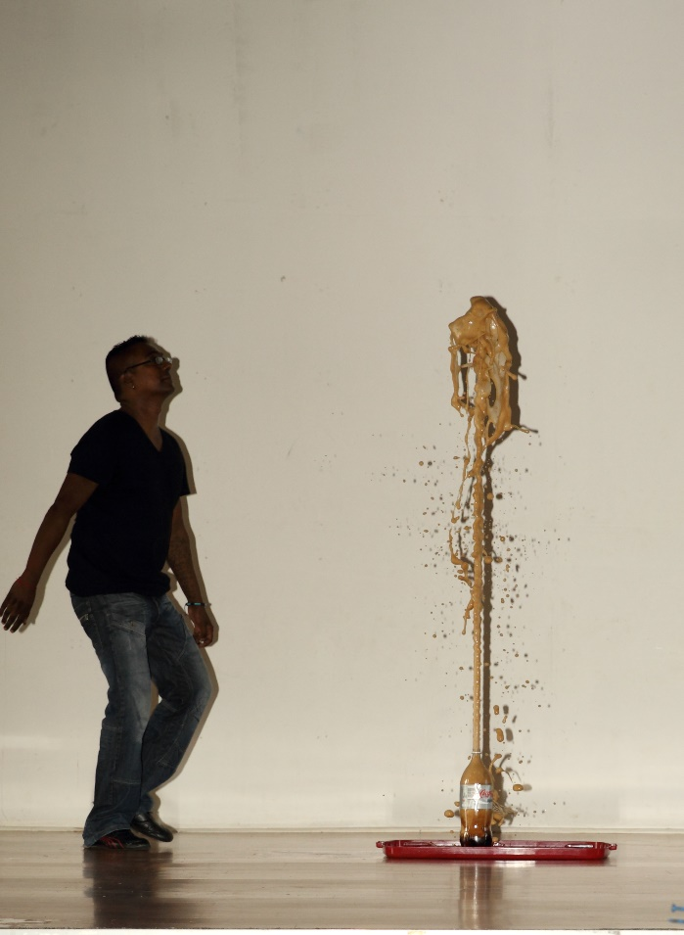

Ll

