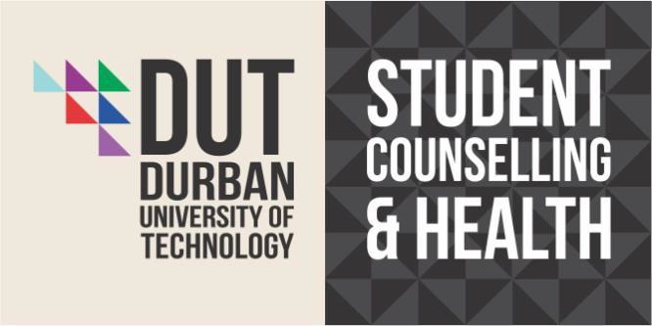

COUNSELLING INTERNSHIP POST 2019:

The Department of Student Counselling and Health of the Durban University of Technology (Durban Campus), is an accredited training institution with the Health Professions Council of South Africa, and is seeking to appoint Counselling Psychologist Interns for 2019.

The intern will be expected, under supervision, to render professional services aimed at facilitating and
supporting the academic, personal, interpersonal and career development of students, and to a lesser extent staff and prospective students.

The intern will be required to offer the following services (under supervision), and as such experience in many or all of these areas would be a distinct advantage:

- Individual and group-based therapy.
- Crisis Counselling and Intervention.
- Career Counselling.
- Academic Guidance and Support.
- Life Skills Development and Training: Academic Study Skills Workshops and Personal Development Workshops.
- Conducting Formal Psychological Assessments.
- Conducting basic research and needs assessments.
- Advocacy.
- Food Security Screening.
- Psycho-Education.

Minimum Requirements:
- Evidence of completion of the M1 examinations.
- Registration with the HPCSA as a Counselling Intern Psychologist for 2019/proof of sent documents for registration.
- Valid Driver’s license.
- Evidence of completion or near completion of M-thesis at commencement of M2 year (internship in counseling psychology). A letter from your Research Supervisor from your University will be needed stating how far you are.

Additional Recommendations:
- Computer literacy (MS Word / Power Point)

Applications should include:
- A detailed curriculum vitae (explicitly stating experience or knowledge in above-mentioned fields)
- Certified copy of identification document.
- Certified certificates of all relevant University academic records and certificates.
- Certified copy of HPCSA Student Psychologist Certificate.
- Current contact information of three referees (one of which must include a direct clinical/therapy supervisor).
- One typed motivation page explaining why you have applied to complete your internship at the Durban University of Technology, Student Counselling Centre, and why you would be a suitable candidate for the Centre. This needs to include assessment exposure.

Please note when applying please put all required documentation on one PDF document. Multiple documents will not be accepted. Details of the interview will be sent closer to the time.

Applications to: Miss Candice Leith (Candicel@dut.ac.za)
Psychologist
Email: candicel@dut.ac.za
Contact: 031-373-2158/2266

Durban University of Technology
Student Counselling and Health (Durban Campus)
Steve Biko Road
P.O. Box 1334
Durban 4000.

*Email application preferred.

Closing date for applications: 31 May 2018

