
DUT 82

APPLICATION FOR CONFERENCE FUNDING

In order to expedite the processing of this application, kindly ensure that:

1. The following supporting documents should be attached:

(a) Relevant correspondence from the conference organisers.

(b) Proof of acceptance of paper (if applicable).

2. The application form has the recommendation of the Head of Department.

3. Thereafter, the application form is forwarded to the Office of the Executive Dean of the Faculty for consideration by the Faculty Exco and submission to the Directorate for Research and Postgraduate Support.

4. Application forms are to be submitted at least EIGHT weeks before the Conference/ Workshop/etc. is scheduled to take place to allow for timeous processing.

NOTE:
- Conference funds are awarded on a competitive basis and depend on the availability of funds at the time of your application.
- Maximum amount awarded for international travel is R40 000.
- Maximum amount awarded for local travel is R15 000.

THE APPLICATION CHECK LIST

Please check that the following is included:

1. Copy of Abstract | Yes |  |  | No

2. Proof of Acceptance | Yes |  |  | No

3. Quotes of flights, accommodation and other | Yes |  |  | No

4. Proof of peer review of abstract/paper | Yes |  |  | No

5. Is this going to be published in a conference proceeding that  includes the following: | Yes |  |  | No
- Editors details;
- Publishers details;
- ISSN number; and
- Proof of peer review?

6.1 When you return from the conference will this paper be sent to an  DHET accredited journal for publication? | Yes |  |  | No

6.2 Please state the name of the Journal?

...............................................................................

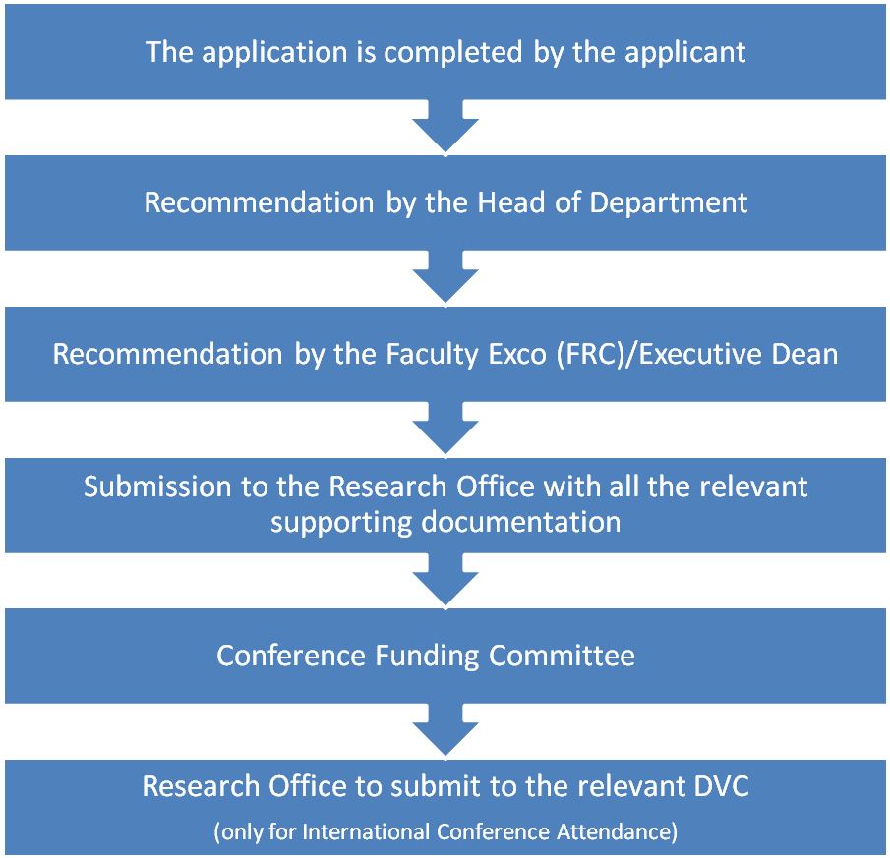

Directorate for Research and Postgraduate Support

Application for funds to attend a conference

Please indicate the category relevant to your application: (Please tick)
i) Local Conference/Workshop - Participation (presentation of a paper/ poster or to chair a session or to serve as a respondent)

ii) Presentation of a paper at an International Conference

A. BIOGRAPHICAL DETAILS

1. | Surname |  | Initials |  | Title

2. | Staff No. |  | 3. | Date of Appointment

3. | Position Held |  | Department

4. | Nature of Employment | Permanent Contract Temporary

5. | If on contract, indicate date of expiry of contract:

6. | Highest Academic Qualification

7. | If presently studying, indicate: the qualification registered for:

Institution at which registered:

8. | If registered at DUT, Indicate student number:

B. CONFERENCE/WORKSHOP DETAILS

1. Title: ........................................................................................................................................

2. Venue: .....................................................................................................................................

3. Dates: From......................................................... To...........................................................

4. Organising Body: ...................................................................................................................

C. PARTICIPATION DETAILS

1. Have you been invited by the Organisers to chair a session? | Yes |  |  | No

If Yes, please furnish proof

1.1 Do you intend to present a paper/poster at the conference? | Paper |  |  | Poster

1.2 Title of presentation: ............................................................................................................................................................................................................................................................................................................
1.3 If this is a joint presentation | Yes |  |  | No

1.4 Are you the presenting author? | Yes |  |  | No

1.5 Is this Conference directly related to your field of research/teaching? | Yes |  |  | No

D. DETAILS OF ESTIMATED EXPENDITURE

1. Travel Expenses (specify) Air.................................... R…...................................

2. Conference Fee: ......................................................... R........................................

3. Pre-booked Ground Travel, Accommodation & Subsistence:... R........................................

4. Other (State)e.g. VISA..................................................... R........................................

TOTAL R

6. What proportion of the above costs will be met by the Conference Organisers?

................................................................................................................................................

7. Have you applied for funding from other sources? | Yes |  |  | No

7.1 If yes, indicate:

7.1.1 Name of Agency: ....................................................................................................................

7.1.2 Amount applied for: .................................................................................................................

7.2. Have you received financial assistance from any other source? | Yes |  |  | No

7.2 If yes, state:

7.2.1 Name of Source: ....................................................................................................................

7.2.2 Amount received:....................................................................................................................

E. DETAILS OF PAST CONFERENCE ATTENDANCE

Please provide information on conferences attended during the past three years:

LOCAL CONFERENCES/WORKSHOPS

Title of Conference | Year | Venue | Participation * | Source(s) of Funds
1.
2.
3.
4.
5.

INTERNATIONAL CONFERENCES OUTSIDE SOUTH AFRICA

Title of Conference | Year | Venue | Participation * | Source(s) of Funds
1.
2.
3.
4.
5.

* Indicate your participation by one of the following symbols:

PP = Paper/Poster Presentation
C = Chair of Session
R = Respondent
A = Attendance Only (i.e. Non-Participation)

F. OUTPUT TRACK RECORD

1. PUBLICATIONS DURING THE LAST THREE YEARS

Please provide details on journal articles, chapters in books, etc. in the following order:

a) JOURNAL ARTICLES

Title of Article:
Author(s) :
Published Accepted but still in Press Submitted
Title of Journal:
Is the Journal SAPSE accredited? Yes No
For published article, provide: Volume................. Page No(s) ................ Year ..........

Title of Article:
Author(s) :
Published Accepted but still in Press Submitted
Title of Journal:
Is the Journal SAPSE accredited? Yes No
For published article, provide: Volume................. Page No(s) ................ Year ..........

Title of Article:
Author(s) :
Published Accepted but still in Press Submitted
Title of Journal:
Is the Journal SAPSE accredited? Yes No
For published article, provide: Volume................. Page No(s) ................ Year ..........

Title of Article:
Author(s) :
Published Accepted but still in Press Submitted
Title of Journal:
Is the Journal SAPSE accredited? Yes No
For published article, provide: Volume................. Page No(s) ................ Year ..........

b) BOOKS/CHAPTERS IN BOOKS/CONFERENCE PROCEEDINGS

Title of Book/Conference Proceedings:
Title of Own Contribution:
Author(s) :
Nature of Contribution : Entire Book Chapter in Book Conf. Proceedings
Publication Details: (as applicable) Year ........... Month ................. Page numbers.........

Title of Book/Conference Proceedings:
Title of Own Contribution:
Author(s) :
Nature of Contribution : Entire Book Chapter in Book Conf. Proceedings
Publication Details: (as applicable) Year........... Month................. Page numbers.........

Title of Book/Conference Proceedings:
Title of Own Contribution:
Author(s) :
Nature of Contribution : Entire Book Chapter in Book Conf. Proceedings
Publication Details: (as applicable) Year........... Month................. Page numbers.........

G. OTHER INFORMATION ON RESEARCH OUTPUT

Please provide other information (not included under E and F above), on significant contribution to Research and Development output over the past three years. This could include activities such as patents, the establishment of a Research Programme/Unit, as well as researched report(s) for NGOs, Industry, etc., which may have significant social/educational/economical impact.

1.
2.
3.

H. ABSTRACT OF PAPER

A COPY OF THE ABSTRACT OF THE PAPER TO BE PRESENTED MUST BE ATTACHED TO THIS APPLICATION FORM
(a) Has this paper been presented at another Conference? | Yes |  |  | No

(b) If yes, state:

NAME OF CONFERENCE | DATE | PLACE

Yes |  |  | No
(c) Has this paper/poster already been published?

(d) If yes state the name of the Journal and reference below

...................................................................................................................................................

For persons invited to Chair a session or act as a respondent, a copy of the invitation must be attached to the application

I. FORMALISATION OF THE APPLICATION

I agree to comply with the following conditions:

* A written report on the conference, symposium, seminar, etc. will be submitted to the Directorate for Research and Postgraduate Support within seven (7) days of returning from your trip.

* In the event of terminating my services at DUT within 6 months from the date of the conference/symposium/seminar, etc., a pro-rata amount of the total cost will be refunded to DUT.

........................................................... ...........................................
SIGNATURE OF APPLICANT DATE

J. RECOMMENDATION BY HEAD OF DEPARTMENT

1. I confirm that:
1.1 The conference is | Internationally recognised |  | Nationally recognised

1.2 The conference is | an Academic conference |  | a Professional conference

2. This application is | Recommended |  | Not recommended

3. INDICATE THE TOTAL NUMBER OF APPLICATIONS THAT WILL BE SUBMITTED BY YOUR DEPARTMENT FOR THIS CONFERENCE

MOTIVATION........................................................................................................................................................................................................................................................................................................................................................................................................................................................................
CAPACITY:  HEAD OF DEPARTMENT | NAME IN PRINT: | SIGNATURE: | DATE:

K. RECOMMENDATION BY FACULTY EXCO (FRC)/EXECUTIVE DEAN:

Faculty EXCO: Before forwarding to the Research Office, please ensure that the application form is properly completed and the following documents are attached :

Conference details (dates, venues, registration fees, itinerary, etc.)

Copy of the abstract

Proof of acceptance of the paper/poster

 | Recommended |  |  | Not Recommended

MOTIVATION: .........................................................................................................................................................

.........................................................................................................................................................

.........................................................................................................................................................

CAPACITY: | NAME IN PRINT: | SIGNATURE: | DATE:

L. CONFERENCE FUNDING COMMITTEE

DATE RECEIVED:

DATE OF MEETING:

AMOUNT APPROVED:

MOTIVATION: .........................................................................................................................................................

.........................................................................................................................................................

.........................................................................................................................................................

CAPACITY:  CHAIR: Conference Funding Committee | NAME IN PRINT: | SIGNATURE:

Please note that for Administrative and Support Staff the application has to be forwarded by the Head of Department to the relevant Director / Senior Manager for recommendation to the Conference Funding Committee

For official Use:

M. SIGNATURE OF RELEVANT DVC (The Research Office will forward to the relevant DVC after approval)

Applications of staff members in the Academic ambit must be signed off by the DVC: T & L
Applications of staff members in the RIE ambit must be signed off by the DVC: RIE

 | Approved |  |  | Not Approved

MOTIVATION: .........................................................................................................................................................

.........................................................................................................................................................

.........................................................................................................................................................

.........................................................................................................................................................

CAPACITY:  DVC: | SIGNATURE: | DATE:

