
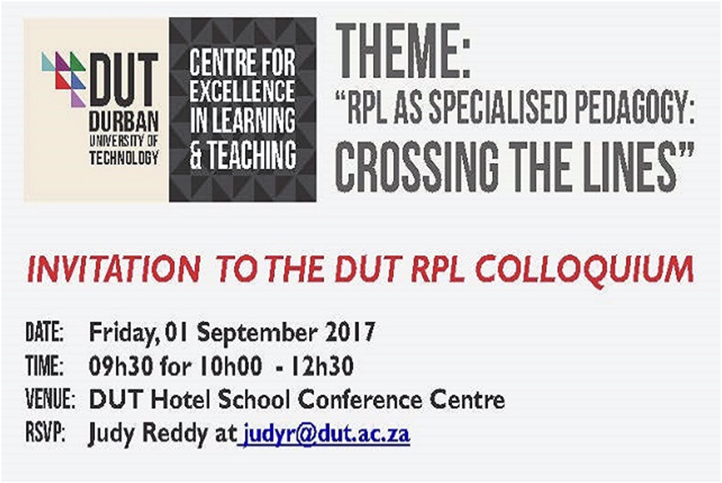
Greening the University Curriculum : Professor Lesley Le Grange
Lesley Le Grange is Distinguished Professor in the Faculty of Education at Stellenbosch University, South Africa. He has 218 publications to his credit and serves on editorial boards of nine peer-reviewed journals. He has delivered more than 170 academic presentations, many as invited speaker. Lesley Le Grange serves on several National Research Foundation (NRF) panels, is Vice-President of the International Association for the Advancement of Curriculum Studies (IAACS), is member of the Council on Higher Education and is a Fellow of the Royal Society of Biology (UK). He is recipient of several academic awards and prizes. This year he received the South African Education Research (SAERA) Honours Award for outstanding contributions to educational research and was also elected member of the Academy of Science of South Africa (ASSAf). Lesley is rated as an internationally acclaimed researcher by the NRF.

TALKING ABOUT TEACHING @DUT:

A SEMINAR ON GREENING THE UNIVERSITY CURRICULUM
The planet we inhabit is on the brink of ecological disaster because environmental problems have reached unprecedented levels – some scientist argue that we have reached a tipping point and that we can no longer reverse environmental destruction. Human-induced changes to the planet over decades, perhaps centuries, have made scientists posit a new Geological epoch the Anthropocene. Destruction in the domain of ecology should be understood transversally. When we witness destruction of ecological systems we will also see destruction of society and the self. The domains of nature, society and self are interlocking. And so healing in one domain will also be witnessed in the other domains. The current state of the planet (in all its interlocking dimensions) brings the perennial existential question to the fore, how should we live, and education questions, how and what should we teach and learn? Also curriculum questions, what knowledge is of most worth, whose knowledge is of most worth and is knowledge enough? One response to the global socio-ecological crisis has been a call for transitioning to a green society/economy. In the workshop some of the complexity around green society/economy transitions will be explored by bringing ecology, poverty and the rapid growth of new technologies into conversation. Moreover, the challenges that this has for curriculum and what actions DUT might take, will be explored.

Date: Wednesday, 13 November 2019
Time: 9h00-11h00
Venue: eMakhosini Hotel (3 Lumsden Crescent, Morningside)
RSVP: Sphesihle Nkosi – sphesihlen@dut.ac.za

