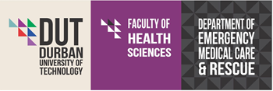
PHD EMC CONCEPT DOCUMENT
Date:
Student Name:
Current Qualification:
Expected year for admission at DUT:
Email address:
Contact number:

Please type in your responses using the boxes provided. The boxes will expand as your text lengthens.
- Briefly describe yourself and what you are currently doing?

- Please provide a short description of your Masters work.

- The Department is glad that you have expressed interest in embarking on what is a lonely and torturous road to the PhD EMC. Prehospital Emergency Care in South Africa can only grow from strength to strength through contextually relevant research. The Doctorate requires a lot of your time and being a 360 credit qualification, you will need to invest at least 3600 notional hours on it. The PhD is a significant jump from the Masters degree and it will help for you to read other theses to understand what is expected of you.
At a PhD level, the NQF requires that you “demonstrate expertise and critical knowledge in an area at the forefront of a field, discipline or practice and the ability to conceptualise new research initiatives and create new knowledge and practice”.
That said, please provide us with the proposed title, research problem, research aim and objectives and proposed methodology. This should be completed in the block below and should not be longer than two pages.

- How do you envisage your work contributing to new knowledge in the discipline?

